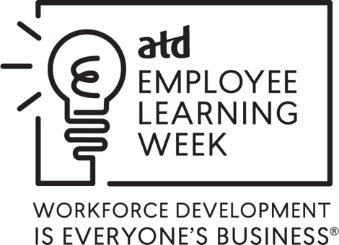

Suggested Steps for Proclamation for Employee Learning Week 2022
In past years, several ATD chapters have worked with local officials to request a proclamation of Employee Learning Week in their town, city, county, or state. Organizations can request proclamations too. Since every locality’s requirements are different, there is not a defined set of steps to follow. However, here are a few reminders or hints that may be helpful when requesting a proclamation:
- The first step is to visit the website of your locality to determine if proclamation requests are accepted, the timeline for making requests, and the information that must be included. Depending on the locality, requests may be directed to an elected official (a Mayor’s office, for example) or a governing body (city/county council). You may need to email the local government’s office for more information if you do not find what you are looking for on the website.

- Most ATD chapters will probably make a request within their town, county, or city. If a chapter is located in the state capital and wants to send a request to the state governor, it may be beneficial to make the request on behalf of ATD chapters and members in the entire state, not just the capital city. If you choose to do this, be sure to communicate with the chapter presidents in your state in advance so that they are aware of your intent to make the request. Even though your request may be made on behalf of several chapters, be sure to identify one person on the chapter board as a point of contact. Make your request early and within the required timeframe. Some localities ask that proclamation requests are done 60 or 90 days in advance, and some may be longer.

- Use the templates we provide as sample language and remember that one size doesn’t fit all! While we hope these items are helpful, they are not prescriptive. Your town, county, or city may require additional information. Your best bet: do the necessary homework, find out what is required, determine one point of contact in your chapter, and provide useful background information when asked.

Questions about the information provided for Employee Learning Week? Email the ATD Communications department at elw@td.org.

Sample Request Letter for a Proclamation
Date
Attention: Person or Official’s Name
Title
Office of the (Official Title)
Address
City, State, Zip Code
Dear (Name),
The Association for Talent Development (ATD), the world’s largest association dedicated to those who develop talent in organizations field, is celebrating December 6-10, 2022 as Employee Learning Week to recognize the value of learning and the important link between a knowledgeable, highly skilled workforce and organizational success. ATD members come from more than 120 countries and thousands of organizations.
On behalf of (your company), we would like (insert local official’s name and title, for example, “Mayor Smith”) to consider this request to proclaim Employee Learning Week in (insert town, city, or state name here). Included with this package is additional background information about ATD and the Employee Learning Week campaign, as well as suggested language for a proclamation.
If you have questions about (your organization name here) or Employee Learning Week, please feel free to contact me by phone or email (insert your contact information). Thank you for taking time to consider this request. We appreciate your help in showcasing the value of employee learning and its connection to the success of our (local) companies and their long-term competitiveness and vitality.
Best regards,
Your Name
Your Title
Company Name

Sample Language for ATD Employee Learning Week 2022 Proclamation
A Proclamation
WHEREAS, the organizations of (town, city, or chapter name) are committed to creating a highly skilled workforce that is critical to growing and sustaining a competitive advantage;
WHEREAS, they recognize that having a knowledgeable, skilled workforce improves the performance of those organizations;
WHEREAS, learning develops individual and organizational knowledge and expertise;
WHEREAS, the Association for Talent Development (ATD)–the world’s largest association dedicated to those who develop talent in organizations –has declared December 6-10, 2022, as “Employee Learning Week” and designated this time for organizations to recognize the value of employee learning;
WHEREAS, the (organization’s name) in (town, city, state) has demonstrated its commitment to developing the skills of employees and the workforce;
NOW, THEREFORE, I, (name), (title) of (town, city, or chapter name) do hereby proclaim December 6-10, 2022 as

EMPLOYEE LEARNING WEEK in (town, city, or state name) AND …
(OPTIONAL AREA FOR INCLUDING ADDITIONAL LOCAL INFORMATION)

