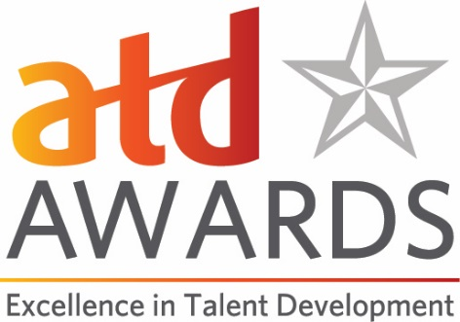

Champion of Talent Development Award Application
This award is presented to an individual from outside the talent development profession. Nominees should demonstrate commitment, advocacy, and actions in support of talent development within or outside an organization. Those actions will have influenced audiences, organizations, or society.

Criteria:
Nominations will be evaluated on the scope and depth of documented advocacy, commitment, and actions that have promoted talent development.
- Evidence of wide-reaching or global support of talent development, upskilling the workforce for the future, and/or learning at work through actions, ideas, writing, or speaking.
- Proof of influencing audiences and/or organizations.
- Proof of a sustained commitment to talent development, reskilling the workforce, or workplace learning as a key driver of organizational impact.
- Evidence the nominee promotes the value of learning and the development of talent as a strategic differentiator for organizations or society.
- Evidence the nominee’s own work demonstrates this commitment.
Eligibility:
- Eligible candidates are individuals from outside the talent development field.
- Past winners have included authors, CEOs/business leaders, researchers, and thought leaders.
- Elected officials are not eligible.
Submission Form:
Please use this document to prepare your application and note the word count limits for questions 1-4. To submit the application, please go to our online Awards portal https://atdawards.secure-platform.com:443/a and submit your entry there. The deadline for submissions is December 15, 2019. Please email Jennifer Homer (jhomer@td.org) if you have any questions.

Champion of Talent Development Application Form
Date of Application:
Name of Nominator (please indicate if this is a self-nomination):
Contact Information for Nominator:
- Name
- Title
- Organization
- Email
- Phone
Nominee Information:
- Name
- Title
- Organization
- Email
- Phone

- Please give a brief history of the nominee’s professional achievements, volunteer service, and/or personal accomplishments. (Please ensure your answer does not exceed 500 words.)

- Describe the nominee’s view of the importance of developing talent, skill development for the future workforce, and/or the value of learning at work. Include specific references to public statements, presentations, or writing that support this. (500-word maximum.)

- The nominee’s work should include multiple examples of the importance of developing talent. Within or outside an organization, describe how the nominee has publicly demonstrated that developing the knowledge, skills, and abilities of people can positively affect organizations and society. Please share specific examples, which can include links to videos, podcasts, speeches, or published material like blogs, articles, research, or books. (500-word maximum)

- Please describe why this nominee is deserving of being chosen as ATD’s Champion of Talent Development. (500-word maximum)

