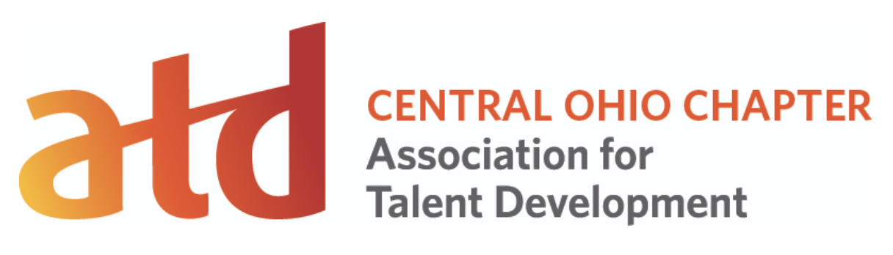Emerging Professionals Showcase & Look & Learn Event
Location: Center on Education and Training for Employment (CETE) 1900 Kenny Road Room 1089, Columbus, Ohio 43210
Room 1089: Auditorium + adjoining kitchen
October 3, 2019 5:00PM-8:00PM
5:00PM: Doors open, networking and food
5:30PM: Welcoming remarks and introduction of coaches (Cara)
1st half of event features emerging professional speakers. Each speaker will give a 15-minute presentation. Speakers will then receive targeted feedback from a panel of coaches. The 2nd half of the event features Look & Learn, our version of DemoFest where you can see examples of eLearning from around the Central Ohio area.
In person speakers:
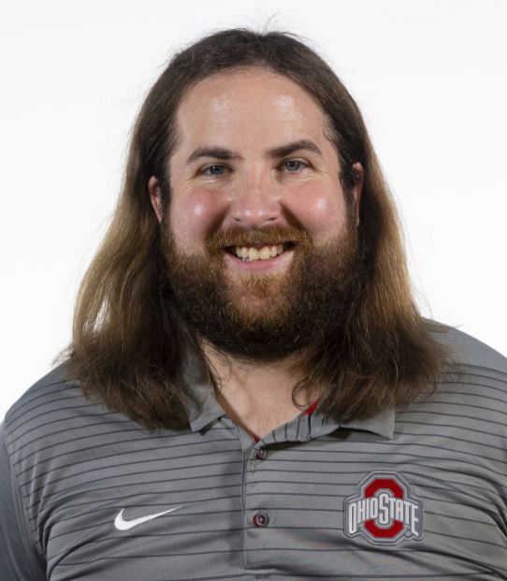Michael Garrett, Videographer, The Ohio State University
Topic: 3 Tips for Using Green Screens 5:35PM
Ankit Shah, Career Counselor, The Ohio State University Alumni Association. Graduate Student pursing Masters of Arts in Workforce Development
Topic: AI & The Evolving Workforce 5:50 PM
Ceren Korkmaz, Graduate Research Assistant, The Ohio State University College of Education and Human Ecology, Office of Research. Graduate Student pursuing a Ph.D. in Educational Studies with an emphasis in Learning Technologies
Topic of presentation: Emotional design in learning experiences

Virtual presenters: (Cara will be virtual presenter producer)
Alex Godinez, Sr.Trainer, Travis Credit Union, Sacramento California. Student pursuing BA in Communication Studies from Sacramento State University 6:20PM
Topic of presentation: How Boxing Relates to Learning and Development

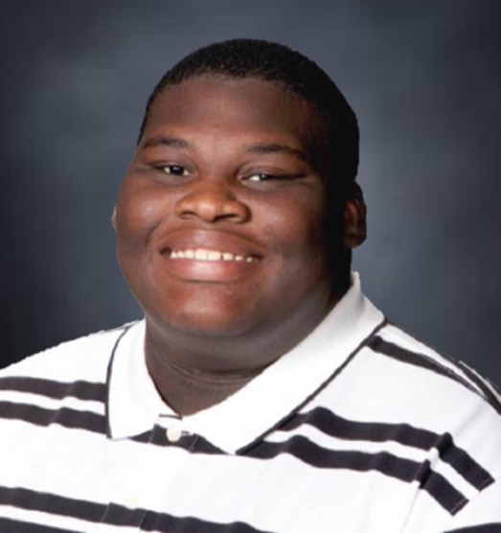Tony Jones, Unit Manager Total Card, Inc, Longview Texas. Recent graduate Master of Education, Educational Technology Leadership from Texas A&M and current Ed.D student, Leadership and Professional Practice, Trevecca Nazarene University
Title of Presentation: Taking the CALL to develop talent in call centers 6:35 PM
-------------------------
Panel of Coaches:
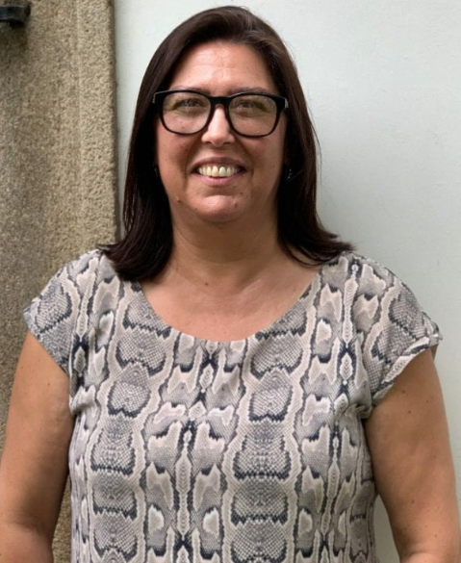 Dr Ana-Paula Correia, Director of the Center on Education and Training for Employment, Associate Professor of Learning Technologies, The Ohio State University
Dr Tracy Shroyer, Owner, Beyond the Stone Wall LLC
Dana Vogelmeier, Owner, Vogelmeier Consulting and President-Elect, Central Ohio ATD
Dr Dawn Snyder, Principal Consultant and Owner, Dawn Snyder and Associates. Adjunct faculty: Franklin University, Boise State University, The Ohio State University
Joseph Suarez, Sr. eLearning Developer, Cardinal Health. Co-lead, Central Ohio Association for Talent and Development’s Technology Special Interest Group
Todd Remer, Learning and Performance Consultant, Nationwide Insurance. Co-lead,Central Ohio Association for Talent and Development’s Technology Special Interest Group
Matt Yauk, Academic Technology Director, The Ohio State University College of Education and Human Ecology.
-------------------------

Look & Learn Event, starts at 7:00PM to give folks time to set up to demo. Can be in the same room or various rooms in the building. Allow 45 minutes for voting.
RFP: https://docs.google.com/forms/d/15ZqCp9qhpf84BZyI0HtfEihTnzRp0hH-BrY5eyAM6nc/
Last 15 minutes to give awards.

