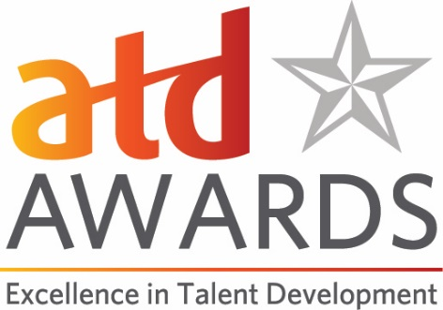

ATD’s One to Watch Award Application
This award is presented to an individual in the talent development profession who is early in their career (five or less years of experience in the talent development field).

Criteria:
- Evidence that this individual is viewed as a leader by peers and colleagues within and outside their organization
- Demonstration of professional achievements or successes in the early part of individual’s talent development career.
- Achievements may include leading successful projects, managing teams, demonstrating exceptional leadership capabilities, mentoring others in or outside the organization, or other successes.

Eligibility:
Eligible candidates are individuals from within the talent development field with five or less years of experience. Elected officials are not eligible.

Submission Process:
Please use this document to prepare your application and note the word count limits for questions 1-5. Please go to our online Awards portal https://atdawards.secure-platform.com:443/a and submit your entry there. The deadline for submissions is December 15, 2019. Please email Jennifer Homer (jhomer@td.org) if you have any questions.

One to Watch in Talent Development Award Application Form
Date of Application:
Name of Nominator (please indicate if this is a self-nomination):
Contact Information for Nominator:
- Name
- Title
- Organization
- Email
- Phone
Nominee Information:
- Name
- Title
- Organization
- Email
- Phone
Is the nominee an ATD Member, ATD Chapter Member, or ATD International Strategic Partner/Global Network Member? Y/N
- Please give a brief overview of the nominee’s professional work and the scope of his or her role. (500-word maximum)
- Describe the nominee’s leadership experience and explain how the nominee demonstrates his or her leadership capabilities within and outside the organization. In this context, leadership could mean leading people (individuals or teams); the nominee’s thought leadership; or strategic leadership on behalf of his or her employer, a volunteer organization (e.g. ATD, ATD chapter, other local/national/international organizations), or other groups. Include specific examples to support this. (500-word maximum)

- Describe the nominee’s professional achievements. Please share specific examples, which can include links to videos, podcasts, speeches, or written material like blogs, articles, research, or books. (500-word maximum)

- Describe a project that the nominee led that showcases how the nominee’s skills and talents contribute to the talent development field in unique, creative, or innovative ways. Explain the quantifiable results and impact that the nominee’s work has had on his or her department, team, or organization. (500-word maximum)

- Please provide an endorsement from the nominee’s manager, a senior leader within the organization, or a knowledgeable senior professional outside of the organization about the contributions the nominee has made to the talent development function in the organization. (500-word maximum)

