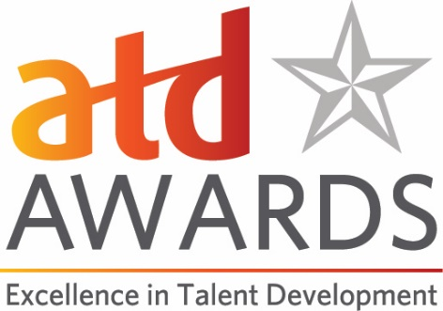
Distinguished Contribution to Talent Development Award Application
This award is presented in recognition of an exceptional contribution to the talent development field that has had sustained impact. This award can be presented to an individual or a team who is actively working in the talent development field.

Criteria:
Nominations will be evaluated on the scope and depth of documented contributions to advancing the development of talent in support of individual and organizational success.
- Evidence the nominees’ work is within the talent development field or a related discipline.
- Evidence the nominees’ work has had a sustained impact (more than five years) on the talent development profession and the individuals working in the field.
- Evidence the nominee(s) are thought leaders who have made and continue to make significant contributions to advancing the development of talent in support of individual and organizational success.
- Evidence the nominees’ work and synthesis of ideas has global application.
- Evidence the nominees’ actions, ideas, methods, concepts, or approaches influence audiences, organizations, and the talent development industry.
- Evidence the nominees’ work, ideas, and concepts have helped talent development practitioners—and the organizations for which they work—achieve results.
- Evidence the nominees’ thought leadership and influence are significant in the field.

Eligibility:
Candidates should be individuals or teams from within the talent development or related field. Elected officials are not eligible. Previous winners include: Peter Senge, Malcolm Knowles, William Bridges, Bev Kaye, Elliott Masie, Ruth Colvin Clark, and more.

Submission Guidelines:
Please use this document to prepare your application and note the word count limits for questions 1-5. To submit the application, please go to our online Awards portal https://atdawards.secure-platform.com:443/a and submit your entry there. The deadline for submissions is December 15, 2019. Please email Jennifer Homer (jhomer@td.org) if you have any questions.
Distinguished Contribution to Talent Development Application Form
Date of Application:
Name of Nominator (please indicate if this is a self-nomination):
Contact Information for Nominator:
- Name
- Title
- Organization
- Email
- Phone
Nominee Information:
- Name
- Title
- Organization
- Email
- Phone
Is the Nominee and ATD Member, ATD Chapter Member, or ATD International Strategic Partner/Global Network Member? Y/N
- Please give an overview of the scope of the nominee’s professional achievements and provide a brief biography of the nominee. (Please ensure your answer does not exceed 500 words.)
- Describe the nominee’s contributions to his or her local community or society, and/or give examples of how the nominee has given back to the profession. (500-word maximum)
- Provide specific examples of the concepts, methods, and approaches used by the nominee to advance individual and organizational talent development. (500-word maximum) Please share these examples, which can include online links or attachments (maximum of two attachments that are no more than three pages each).

- Describe the broad and sustained impact of the nominee’s work over a minimum of five (5) years, including global implications. Include specific examples and references to public statements or presentations, articles, curriculum, published material, videos, or other written work that support the nominee’s broad implementation and sustained impact across the talent development field. (500-word maximum)

- Please describe the unique value this nominee brings to the talent development industry and why this nominee is deserving of being chosen for ATD’s Distinguished Contribution to Talent Development. (500-word maximum)

