ATD LOS ANGELES
BOARD OF DIRECTORS
6th Strategic Leadership Planning Meeting &
Operating Plan
September 18, 2021

TABLE OF CONTENTS
Agenda 3
GOVERNANCE
Mission and Vision 4
Board Member Code of Conduct 4
2022 Board of Directors Roster & Organizational Chart 7
2022 Board of Directors Schedule of Meetings 10
FINANCE
2021 YTD Financial Report & Budget 11
2021 ANNUAL REPORT AND 2021/2022 CHAPTER LEADER INITIATIVES & REPORTS
2021 State of the Chapter & President’s Annual Report 15
2021/2022 Board Member Initiatives/Action Plans & Chapter Leader Reports
President 17

Secretary 18
Member-at-Large 20
Member-at-Large2 22

Director Chapter Meetings (Incoming) 24

Director Volunteers 25
Director Workshops & Webinars 26

Social Media Manager Report (2021) 27
Mentor Program Administrators Report (2021) 29
2022 ANNUAL GOALS
2021 Annual Goals 32
2022 Annual Goals Group Work Plan Assignments 33
Goals Templates 34

ATD-LA 2021 STRATEGIC LEADERSHIP PLANNING MEETING
AGENDA
SEPTEMBER 18, 2021, 10AM-1PM

TOPIC | TIME | BOARD MEMBER(S) | NOTES
Welcome, Introductions & Approval of August Minutes | 10:00am – 10:20am | Kavita Gupta/All/Sara Padilla-Casillas
President’s Report & 2022 Initiatives | 10:20am – 10:25am | Kavita Gupta
Financial Report & 2022 Initiatives/Updates | 10:25am – 10:30am | Anna Halbur
Review of 2022 BOD New Chapter Business & Initiatives/Action Plans | 10:30am – 10:40am | All | Read each board member’s initiatives & plans for 2022
Q&A and Discussion of 2022 Board Member Initiatives/Action Plans | 10:40am – 11:00am | All
Group Work – Develop 2022 Goals | 11:00am – 11:30am | All | Break into small groups and work on assignments
Discussion of 2022 Goals | 11:30am – 12:00pm | All | Group presentations and discussion
LUNCH | 12:00pm – 12:30pm
Wrap-Up & Action Items | 12:30pm - 1:00pm | Kavita Gupta/Sara Padilla-Casillas

Attire: Business Casual
Please bring your laptop if possible

MISSION AND VISION
ATD-LA’s mission is to provide local presence with the best practices in workplace learning and performance.
ATD-LA’s Vision is: Member satisfaction, Local presence, Accountability, Optimal use of resources
BOARD MEMBER CODE OF CONDUCT
This policy reflects a commitment to a standard of behavior expected of every board member and volunteer at the Los Angeles Chapter of the Association for Talent Development (ATD-LA). Board members and volunteers play a critical role as chapter leaders and should strive for the highest standard in honoring the chapter’s vision and mission. All board members and volunteers must show respect, professionalism and courtesy in all their interactions to each other and to members of the organization. The Executive Committee will have the discretion to recommend to the board corrective action, including and up to termination, of a board member or volunteer found to have violated this policy.
DEFINITIONS
A board member is defined as one filling the role of the board position as stated in the chapter bylaws. A volunteer is defined as one who has agreed to assist a board member or the chapter in any capacity for chapter operations and functions. Bullying is defined as an ongoing and deliberate misuse of power in relationships through repeated verbal, physical and/or social behavior that intends to cause physical, social and/or psychological harm. It can involve an individual or a group misusing their power or perceived power, over one or more persons who feel unable to stop it from happening. Harassment can be a single event or a pattern of conduct that is based on a characteristic protected by applicable law, the effect of which is to create a board business environment that is hostile, offensive, or intimidating.
All ATD-LA board members are expected to undertake the following code of conduct during their term:
RESPONSIBILITIES
● Be informed about the organization’s mission, services, policies, and programs.
● Fulfill responsibilities as described in the job description that pertains to each board member’s role, found in the Position Descriptions https://atdla.org/page-1819156 and responsibilities as outlined by each board member in their Fall or Winter Action Plans.
● Serve with integrity, respect and accountability.
● Attend at least 10/12 board and committee meetings and special events or meetings when possible. An absence of 3 or more meetings per year can result in a review of a board member’s commitment to their role by the Executive Committee and appropriate action taken. Attendance at meetings does not include any months in which board meetings may not be held.
● Designate a replacement or backup for tasks, projects, reports or other relevant responsibilities in the
event of an absence or emergency.
● Prepare board reports prior to each board meeting by the Wednesday before each board meeting, submit board reports to the Secretary by the due date and review meeting agenda and any supporting materials prior to each board meeting.
● Give an oral report at monthly board meetings if deemed necessary. Oral reports are expected at all monthly board meetings from the president, finance and membership directors.
- ● Inform others about the organization. Advocate for the organization. Serve as an ambassador for ATD-LA.
- ● Suggest possible nominees to the board who can make significant contributions to the work of the board.

- COMMUNICATION
- ● Conduct all written or verbal communication with other board members, chapter administrators, peers, members or volunteers with respect and courtesy and refrain from slander, accusations or false information in any and all communications.
- ● In the event of conflict of interest or misunderstandings between board members, chapter administrators or volunteers, adopt the following protocols for resolving the conflict:
  - ● Request an in-person or virtual meeting with the Executive Committee to apprise them about the issue at hand.
  - ● Refrain from sending any further emails to anyone that can exacerbate the situation.
  - ● Follow steps or actions to rectify the situation as laid out by the president and/or committee assigned to resolve the situation.

  - CONDUCT, RESPECT & PROFESSIONALISM
- ● Demonstrate professional competence, fairness, impartiality, efficiency, and effectiveness. Promote a positive atmosphere at all board meetings or chapter events.
- ● Serve with respect, concern, courtesy, and responsiveness in carrying out the organization’s mission.
- ● Demonstrate the highest standards of personal integrity, honesty, and fortitude in all activities in order to inspire confidence and trust in our activities.
- ● Refrain from investigating or discussing another board member’s performance without the Executive Committee’s authorization.
- ● While confidential and/or sensitive information such as financial, personal and other matters concerning the organization, donors, staff or members may be included in board materials or discussed from time to time, board members must uphold the confidentiality nature of such information.
● Examples of behavior that should be avoided includes but is not limited to:
- Aggressive behavior such as shouting, abusive language, threats of violence, making accusations or demands, or non-verbal expressions of aggression;
  - - Behavior that a reasonable person would find to be demeaning, discriminating, humiliating, harassing, or bullying;
  - - Communicating with an officer, president, chapter administrator or volunteer either verbally or in writing using offensive or unprofessional language or tone that would be perceived as a personal attack toward an individual, including Board Member to Board Member.

  - LEAVE OF ABSENCE
- A board member may request a leave of absence from the board for health, work, or other reasons that make the board member unable to participate fully or complete assignments during a term. A board member can take a three-month leave during the first year of their term. This time will count toward the requirement to fulfill the board member’s duties. If a board member is unable to fulfill the requirements for completing their duties, then a president can reassign tasks or the issue can be presented to the Executive Committee for a decision.
CONFIDENTIALITY AND PRIVACY
- All board and chapter information should be handled properly in order to protect it from inappropriate access, use, and disclosure.
REPORTING INAPPROPRIATE BEHAVIOR
- ● Board members and volunteers should report conduct contrary to this policy on professionalism to the Executive Committee. The President or the Executive Committee shall take timely and appropriate action, as determined by the Executive Committee, to address the reported conduct in accordance with the chapter bylaws. Violations may also be reported to the ATD Chapter Relations Manager who will follow up with the President or the Executive Committee of the chapter.
- ● Board members should avoid actions or communications that could be perceived as retaliation or retribution for someone reporting or supplying information about a violation of this policy. The essence of this clause is to encourage board members and board volunteers to speak up and to do so within a safe
              - environment.

- ACCOUNTABILITY
- Acceptance of a board role with ATD-LA signifies acceptance of the terms and conditions outlined in this policy. Failure to observe and abide by this policy may result in corrective action as determined by the Executive Committee with approval of the board.

Board Member Signature: _________________________________________

Date: __________________________

2022 BOARD OF DIRECTORS ROSTER & ORGANIZATIONAL CHART
EXECUTIVE COMMITTEE

PRESIDENT Kavita Gupta, 480.225.5646
president@atdla.org
SECRETARY Sara Padilla-Casillas, 562.318.6331
secretary@atdla.org
CHIEF FINANCIAL OFFICER TBD
treasurer@atdla.org
BOARD OF DIRECTORS
MEMBER-AT-LARGE Anupa Naik, 646.413.0445
DIRECTOR COMMUNITIES OF PRACTICE atlarge@atdla.org
MEMBER-AT-LARGE Mariam Manukyan, 323.513.3819
atlarge2@atdla.org
DIRECTOR CHAPTER MEETINGS Allesaundra Mills, 310.736.5445
chaptermeetings@atdla.org
DIRECTOR MEMBERSHIP James McKenna, 310.619.9161
membership@atdla.org
DIRECTOR VOLUNTEERS Valerie Quezada, 818.281.1147
volunteers@atdla.org
DIRECTOR WORKSHOPS & WEBINARS Princess Walsh, 914.325.0806
workshops@atdla.org
OFFICE ADMINISTRATION
OFFICE MANAGER Denise Ross, 562.908.3020
office@atdla.org
OFFICE ADMINISTRATOR Grant Skakun, 213.663.2385
officeadmin@atdla.org

COMMUNITIES OF PRACTICE LEADERS
NON-PROFIT SIG Esther Ramirios, 213.268.6670
nonprofittrainerssig@atdla.org
SOUTH BAY GIG Sue Gabriele, 310.848.7740
southbay1@atdla.org
SOCAL YOUNG PROFESSIONALS SIG Michelle Yang, 626.380.5004
Nairee Bedikian, 818.689.3610
youngprofessionals@atdla.org
SANTA CLARITA GIG Paul Butler
TBD
CHAPTER MANAGERS
SOCIAL MEDIA MANAGER Scott Moe
socialmedia@atdla.org
ORIENTATION FACILITATOR Guy Morgenshtern, 310.425.9128
gmorgenshtern@gmail.com
VOLUNTEERS
Chapter Meetings Clarissa Pitts TBD
Mentor Program Administrators TBD
Kevin Kwan, kevin.kwan@pandarg.org
Membership Ambassador Maura Lemon, maura.lemon@gmail.com

ATD-LA BOARD OF DIRECTORS ORGANIZATIONAL CHART

ATD-LA 2022 BOARD OF DIRECTORS SCHEDULE OF MEETINGS
9AM-10AM, 2nd Saturday of the Month

JANUARY 15 STRATEGIC PLANNING MEETING (IN-PERSON), Gupta Meeting Room, USC TCC 432
FEBRUARY 12 VIRTUAL
MARCH 12 VIRTUAL
APRIL 9 VIRTUAL
MAY 14 VIRTUAL
JUNE 11 VIRTUAL
JULY 9 VIRTUAL
AUGUST 13 VIRTUAL
SEPTEMBER 17 STRATEGIC PLANNING MEETING (IN-PERSON), Kavita’s House
OCTOBER 22 VIRTUAL
NOVEMBER 12 CURRENT/INCOMING
BOARD HANDOFF & TRANSITION
DECEMBER 10 VIRTUAL

NOTE: Board member attendance is required at all board meetings or a minimum of 10 meetings per year. Timings for in-person meetings may vary. Attire for board meetings is smart or business casual.
2021 YTD FINANCIAL REPORT & BUDGET (as of 9/1/21)
Business Checking Plus
Activity Summary
Ending Balance this Statement $90,574.83
Restrictions $3,500 for Mira Gold New Board Member Award, $755 for 2021 KG Talent Development Membership Grant, $2,000 for ICE Volunteer Coordinator Expenses
Reserves Available $84,244.96
Ending Balance August 31, 2021 $90,574.83
Total Income $11,053.62
Total Expenses $10,981.63
Net Income $71.99

ATD - LOS ANGELES CHAPTER, INC.
Budget vs. Actuals: FY_2021 - FY22 P&L – ANNA HALBUR, CFO
April 2021 - July 2022
 | Total
 | Actual | Budget | over Budget | REVISED FORE-CAST
Income
CHAPT MTGS REVENU - PRGMS | - | - | -
01-April Program Revenue | 136.00 | 80.00 | 56.00 | 136.00
03-June Program Revenue | 87.00 | 80.00 | 7.00 | 87.00
04-July Program Revenue | - | 80.00 | (80.00) | 80.00
05-August Program Revenue | - | 100.00 | (100.00) | 100.00
07-October Program Revenue | - | 80.00 | (80.00) | 80.00
09-December Program Revenue | - | 600.00 | (600.00) | 600.00
10-January Program Revenue | - | 600.00 | (600.00) | 600.00
11-February Program Revenue | - | 600.00 | (600.00) | 600.00
12-March Program Revenue | - | 600.00 | (600.00) | 600.00
Total CHAPT MTGS REVENU - PRGMS | 223.00 | 2,820.00 | (2,597.00) | 2,883.00
MARKETING REVENUE | - | - | -
Website/Interchange Advertising | 325.00 | 250.00 | 75.00 | 325.00
Total MARKETING REVENUE | 325.00 | 250.00 | 75.00 | 325.00
MEMBERSHIP REVENUES | - | - | -
New Member-Individual | 775.00 | 2,322.00 | (1,547.00) | 2,322.00
New Member-Student | 100.00 | 1,008.00 | (908.00) | 1,008.00
Power Member from Store | 1,722.09 | 2,739.19 | (1,017.10) | 2,739.19
Renewal-Corporate | 560.00 | 2,028.00 | (1,468.00) | 2,028.00
Renewal-Individual | 1,562.12 | 5,346.00 | (3,783.88) | 5,346.00
Renewal-Student | 50.00 | 276.00 | (226.00) | 276.00
Total MEMBERSHIP REVENUES | 4,769.21 | 13,719.19 | (8,949.98) | 13,719.19
SPECIAL DIVISIONS REVENUE | - | - | -
Non-Profit Trainers | 270.00 | 500.00 | (230.00) | 500.00
Organizational Development | 10.00 | - | 10.00 | 10.00
South Bay | 10.00 | 50.00 | (40.00) | 50.00
Young Professionals | 110.00 | - | 110.00 | 110.00
Total SPECIAL DIVISIONS REVENUE | 400.00 | 550.00 | (150.00) | 670.00
TREASURER'S REVENUES | - | - | -
ChIP Program | 280.80 | 750.00 | (469.20) | 750.00
Interest & Dividends | 2.33 | 10.00 | (7.67) | 10.00
Total TREASURER'S REVENUES | 283.13 | 760.00 | (476.87) | 760.00
WEBINAR REVENUES | - | - | -
01 April Webinars | 315.00 | 60.00 | 255.00 | 315.00
02 May Webinars | 60.00 | 60.00 | - | 60.00
08 Nov Webinars | - | 60.00 | (60.00) | 60.00
10 Jan Webinars | - | 60.00 | (60.00) | 60.00
11 Feb Webinars | - | 60.00 | (60.00) | 60.00
Total WEBINAR REVENUES | 375.00 | 300.00 | 75.00 | 555.00
WORKSHOPS / PROF DEV REVENUE | - | - | -
03 June Workshop Rev | 2,753.00 | 2,920.00 | (167.00) | 2,753.00
06 September Workshop Revenue | - | 16,794.00 | (16,794.00) | 16,794.00
07 October Workshop Revenue | - | 4,085.00 | (4,085.00) | 4,085.00
Total WORKSHOPS / PROF DEV REVENUE | 2,753.00 | 23,799.00 | (21,046.00) | 23,632.00
Total Income | 9,128.34 | 42,198.19 | (33,069.85) | 42,544.19
Gross Profit | 9,128.34 | 42,198.19 | (33,069.85) | 42,544.19
Expenses
CHAPTER MTGS EXPENSES | - | - | -
01 April Chapter Mtg Expenses | - | 50.00 | (50.00) | -
03 June Chapter Mtg Expenses | - | 50.00 | (50.00) | -
04 July Chapter Mtg Expenses | - | 50.00 | (50.00) | 50.00
07 October Chapter Mtg Expenses | - | 50.00 | (50.00) | 50.00
09 Dec Chapter Mtg Expenses | - | 550.00 | (550.00) | 2,000.00
10 January Chapter Mtg Expenses | - | 1,000.00 | (1,000.00) | 1,000.00
11 Feb Chapter Mtg Expenses | 25.00 | 1,000.00 | (975.00) | 1,000.00
12 March Chapter Mtg Expenses | 25.00 | 1,000.00 | (975.00) | 1,000.00
Total CHAPTER MTGS EXPENSES | 50.00 | 3,750.00 | (3,700.00) | 5,100.00
CHAPTER OFFICE EXPENSES | - | - | -
Management Fee | 4,716.00 | 18,864.00 | (14,148.00) | 18,864.00
Supplies | 59.65 | 500.00 | (440.35) | 500.00
Telephone | 64.74 | 300.00 | (235.26) | 300.00
Total CHAPTER OFFICE EXPENSES | 4,840.39 | 19,664.00 | (14,823.61) | 19,664.00
MARKETING EXPENSES | - | - | -
Constant Contact | - | 798.00 | (798.00) | 798.00
Web Dev'pment & Design | 1,578.34 | 3,326.61 | (1,748.27) | 3,326.61
Total MARKETING EXPENSES | 1,578.34 | 4,124.61 | (2,546.27) | 4,124.61
PRESIDENT'S EXPENSES | - | - | -
Awards & Recognition | 500.00 | 1,000.00 | (500.00) | 1,000.00
Leadership Dev Clinics/Board Mt | 446.42 | 250.00 | 196.42 | 250.00
Nat'l Leadership Conf (ALC) | (2,000.00) | 2,400.00 | (4,400.00) | 700.00
Total PRESIDENT'S EXPENSES | (1,053.58) | 3,650.00 | (4,703.58) | 1,950.00
SPECIAL INTEREST GROUPS | - | - | -
Presenter Honorarium | 30.00 | - | 30.00 | 30.00
Total SPECIAL INTEREST GROUPS | 30.00 | - | 30.00 | 30.00
TREASURER'S EXPENSES | - | - | -
Bank Charges | 284.46 | 1,200.00 | (915.54) | 1,200.00
Insurance Premiums | - | 943.00 | (943.00) | 943.00
Misc. Exp./Postage/Taxes | 117.14 | 50.00 | 67.14 | 117.14
Professional Services | - | 1,000.00 | (1,000.00) | 1,000.00
Total TREASURER'S EXPENSES | 401.60 | 3,193.00 | (2,791.40) | 3,260.14
WEBINAR EXPENSES | - | - | -
03 June Webinars Wex | - | 1,460.00 | (1,460.00) | -
06 Sept Webinars Exp | - | 14,274.90 | (14,274.90) | 14,274.90
07 October Webinars Exp | - | 150.00 | (150.00) | 150.00
Webinar Platform Subscription | 74.95 | 139.95 | (65.00) | 139.95
Total WEBINAR EXPENSES | 74.95 | 16,024.85 | (15,949.90) | 14,564.85
WRKSHPS/PRO DEV EXPENSES | - | - | -
03 June Workshop Exp | 1,852.00 | - | 1,852.00 | 1,852.00
Total WRKSHPS/PRO DEV EXPENSES | 1,852.00 | - | 1,852.00 | 1,852.00
Total Expenses | 7,773.70 | 50,406.46 | (42,632.76) | 50,545.60
Net Operating Income | 1,354.64 | (8,208.27) | 9,562.91 | (8,001.41)
Net Income | 1,354.64 | (8,208.27) | 9,562.91 | (8,001.41)

2021 STATE OF THE CHAPTER & PRESIDENT’S ANNUAL REPORT
Dear Member and Friends of the Chapter,

It is with pleasure that I share the 2021 ATD-LA State of the Chapter and Annual Report. Thanks to a dedicated board, volunteers and your support, we had another strong year. I look forward to your continued participation in the chapter. Here’s to a great 2022!

Kavita Gupta
ATD-LA President 2020-2023

COMMUNICATIONS
Increased followership on ATD-LA’s LinkedIn platform by over 13%.
Actively posted over 45 events and announcements on ATD-LA’s LinkedIn platform with almost 1,200 views on select posts.
Averaged 700 web visits/month and 31k impressions on the ATD-LA website. Website visitors include professionals from business development, HR, education, community and social services and program management.

FINANCE
Introduced a Budget Variance Analysis into the chapter’s monthly budget report.
Awarded $1,000 from the Mira Gold Grant to new board members Mariam Manukyan and Princess Walsh co-created by Lifetime Member, Kenneth Nowack to advance professional career development.
Launched the KG Talent Development Grant in January donated by President Kavita Gupta and awarded 20 membership grants totaling $1,745 to members and non-members.

GOVERNANCE
Introduced a Code of Conduct for board of directors and volunteers.
Achieved 100% Chapter Affiliation Requirements (CARE).
Updated the election materials on the website and instituted a new board member nomination policy overseen by a Nominations Committee.
Partnered with Diana Mailly, CPA who will be the chapter’s new tax accountant.
Started a comprehensive Standard Operating Procedure Central Online Management System for board members target completion date Fall 2022.
Improved chapter leadership best practices with the attendance of 5 incoming chapter leaders at the annual Chapter Leaders Conference hosted by ATD Global.
Revised the Volunteer Recognition Awards to better meet chapter needs with the help of Past President Sean Bloch.

MEMBERSHIP
Increased membership by 5.5% despite the pandemic through the KG Talent Development Grant, strong program offerings, membership drives, and outreach efforts. Maintained our national status as a top 10 largest chapter among 90+ chapters nationwide.
Added a new corporate member, Herbalife Nutrition.
Started a monthly recognition for renewing members in the eweekly newsletter.
Supported several ATD Global Power Membership drives including a Sizzling Summer Special and an upcoming Black Friday Special for chapter members.
Awarded a complimentary certificate from ATD National to board secretary Sara Padilla-Casillas who completed an ATD Certificate in Management Development.

OPERATIONS
Updated the membership database by removing over 1,500 inactive members.
Updated the website and removed outdated information.
Revised advertising and sponsorship rates and received 2 new sponsorships.
Revised the job board and now collaborate with sister chapters in the western region to promote job offerings.

PROGRAMMING
Hosted over 600 members and guests at chapter meetings, orientations, webinars, workshops and communities of practice meetings.
Relaunched the mentor program started by Past President Anthony Lewis after a 5-year hiatus with 29 mentors and mentees.
Relaunched the Annual Volunteer Recognition and Awards program started by past presidents of ATD-LA after almost a decade.
Launched a new SoCal Young Professionals Special Interest Group in collaboration with the Orange County and San Diego chapters.
Co-hosted the International Conference and Exposition (ICE) in Salt Lake City with the Rocky Mountain Chapter and oversaw 70+ volunteers led by Valerie Quezada, ICE Volunteer Coordinator.
Secured proclamations from senior government officials for Employee Learning Week in December.

STRATEGIC PLANNING
Hosted the first Leadership Retreat for 12 board members, office administrators and volunteers.
Held the 5rd and 6th leadership strategic planning leadership meetings attended by board members, chapter leaders and office administrators in winter and fall.
Increased leadership involvement by adding 3 new board members and 4 new chapter leaders and volunteers.
Identified a president-elect for 2023.

Enjoy the ATD-LA 2021 year-in-review video here here https://www.youtube.com/watch?v=7FmugyluwEQ
Thank You Members and Friends of ATD-LA!

2022 NEW CHAPTER BUSINESS & BOARD MEMBER INITIATIVES/PLANS
PRESIDENT’S INITIATIVES – KAVITA GUPTA
- Continue to oversee chapter governance, operations, finance, programming, marketing and communications for the chapter as outlined in the President’s Standard Operating Procedures (see below).
- Oversee the development of an online Standard Operating Procedure Central Online Management System to be completed by Fall 2022.
- Oversee the removal of outdated information from the website archives with the Office Administrator.
- Oversee a senior learning leaders’ panel in February 2022.
- Initiate the development of a President’s Advisory Council that will be comprised of 5-7 past presidents by Fall 2022.

ATD-LA President’s Master Standard Operating Procedures
(to be incorporated into the Chapter Online Management System by Fall 2022)

I.Governance
Board Roster & Organizational Chart
Position Descriptions
Bylaws
Code of Conduct
Articles of Incorporation
State of California Filing
Bi-Annual Strategic Planning Documents & Operating Plans
CARE Report
Annual Report
Nominations Committee Election Forms

II.Finance
Financial Metrics
Budget
Finance Policy
Expense Reimbursement Form
Quickbooks use login and password to access account
Wells Fargo Account use login and password to access account
Mira Gold Restricted Fund
KG Talent Development Restricted Fund

III.Administrative
Monthly Board Meetings & Board Reports
Board and Volunteer Retreat 5/18/21
Monthly President’s Message
Chapter Metrics Reports
Office Manager Contract
Office Administrator Contract
Bi-Monthly Admin Phone Meetings
Administrative Database & Records
New Board Member Onboarding
Tax Accountant & Tax Filings
Directors & Officers Insurance
Liabilities Insurance
Office Phone
Monthly Chapter Leader Calls
Annual Chapter Leader Conference
Job Board

IV.Marketing & Website Management
ATD-LA Website
Constant Contact
Wild Apricot
GoDaddy
Gmail and Google Docs
Advertising, Sponsorships & Partners

V.Social Media
ATD-LA LinkedIn page
Zoom Account
LinkedIn Social Media Account

VI.Programming
Chapter Meetings Guidelines & Annual Plan
Volunteer Orientation Onboarding Guidelines
Workshops & Webinars Guidelines & Annual Plan
Employee Learning Week
Mentor Program
Communities of Practice
Non Profit Trainers Special Interest Group
South Bay Geographic Interest Group
SoCal Young Professionals Group
Santa Clarita Geographic Interest Group
Annual Holiday Party & Volunteer/ATD-LA Partner Recognition

VII.Membership
Membership Metrics & Financials
Welcome Packet
New Member Orientation
Membership Directory
Membership Ambassador
Membership Specials – Valentine’s Day, Summer Sizzler and Black Friday Special
Power Member Specials from ATD Global
New Member Recognition in eweekly (monthly)
Member Renewal Recognition in eweekly (monthly)
Retention Strategy
Annual Membership Satisfaction Survey
SECRETARY INITIATIVES – SARA PADILLA-CASILLAS
Continue to do the following:
- Board Meetings: Support board of directors’ meetings by gathering board reports, keeping meeting minutes, and assembling documents for review before each meeting. Post meeting minutes to the ATD-LA website.
- Governance: Oversee, update, and enforce the chapter’s bylaws and the board’s code of conduct. Serve on the Executive Committee to review cases and recommend appropriate action to the board.
- Staffing: Serve on the Nominations Committee to review nominations, conduct interviews with other committee members and advise on the selection of incoming board members.
Accomplishments for 2021:
- Board Meetings: Created a folder system in the shared Google Docs to streamline the process of gathering board reports and sharing meeting documents. See picture below.
- Governance/Accountability: Suggested edits to Code of Conduct, which was adopted by the board. Achieved 100% participation for signature acknowledgments.
Goals for 2022:
- Accountability: Create a system to track attendance at board meetings.
- Administrative: Organize board meeting-related documents into new central document management system.
- Transition: Identify a successor for the secretary position and train them.
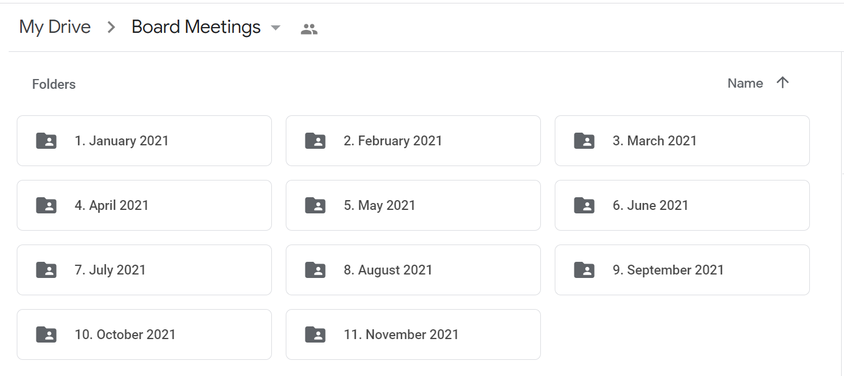

MEMBER-AT-LARGE INITIATIVES – ANUPA NAIK
- 2021 Accomplishments Summary
  - Worked with COPs leads as all meetings went virtual. Strongest engagement was from the Non-profit and Young Professionals groups.
  - Assisted with Chapter Meetings leadership.
  - Developed New Board Member Orientation.
  - Assessed South Bay GIG participation and moved it from monthly in 2021 to quarterly for 2022.
  - Discontinued OD SIG meetings due to lack of commitment from SIG leaders.
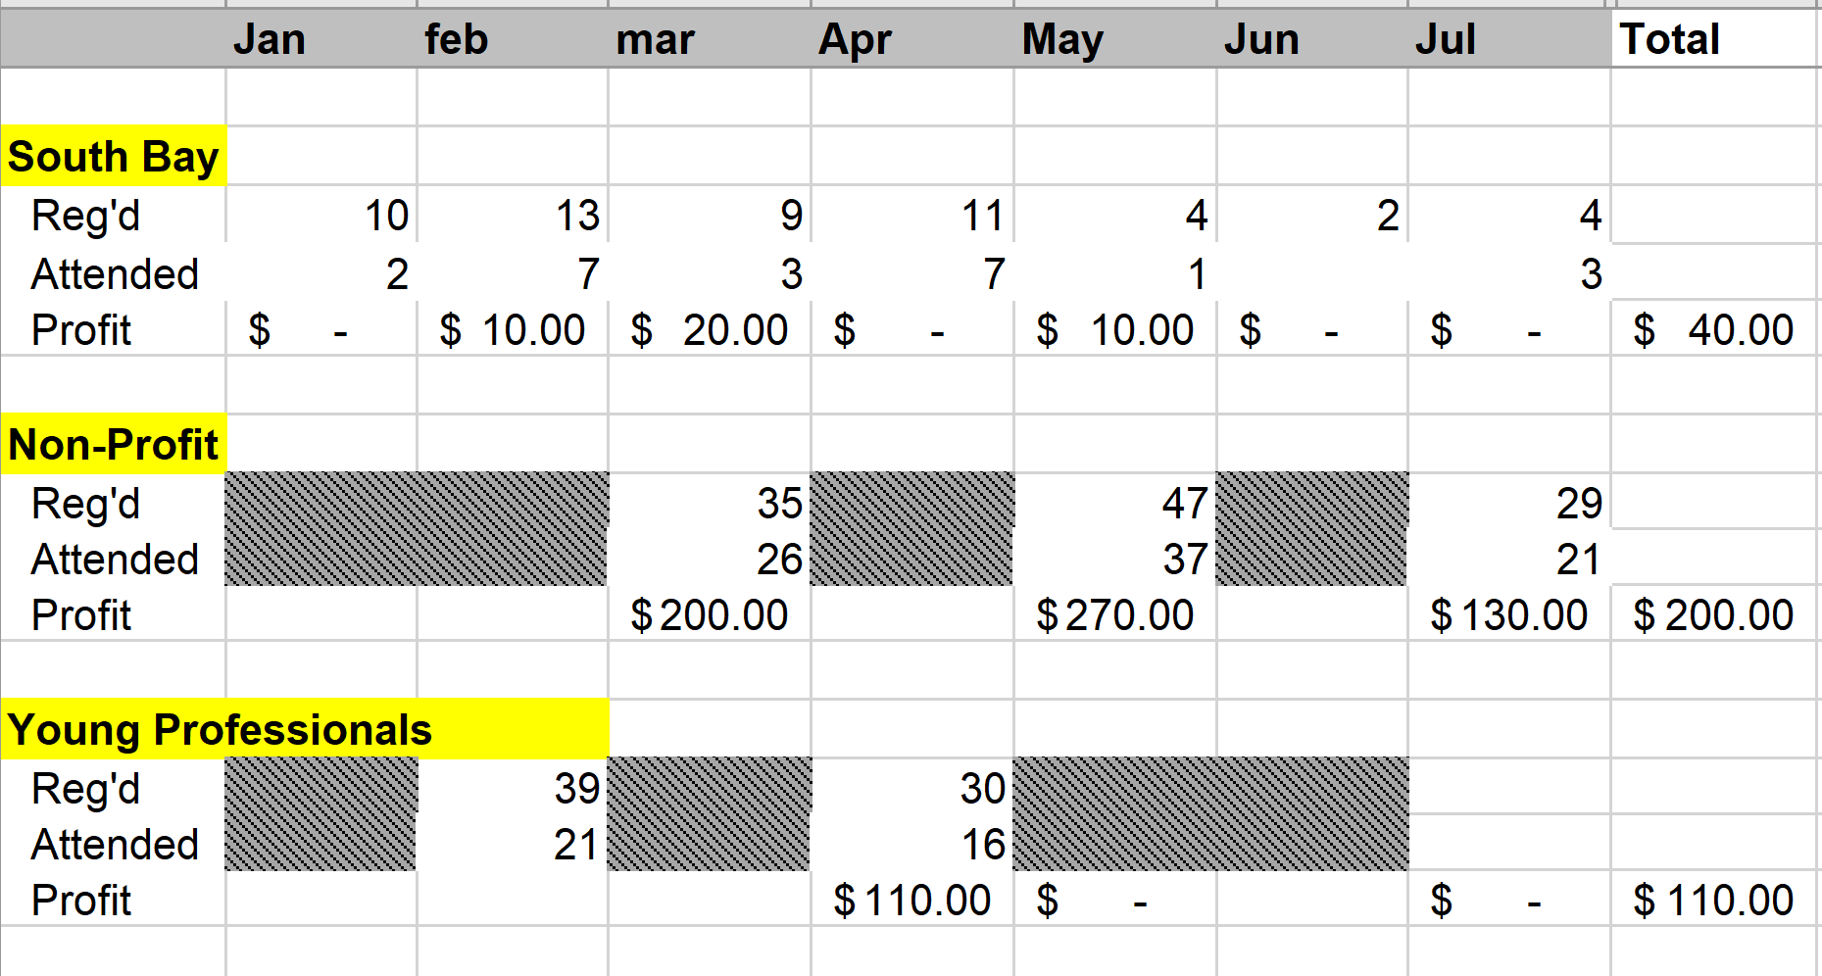

2022 Plan
- Oversee COPs, new Board Member Onboarding, other tasks/projects as needed.
- Monitor and communicate attendance and member engagement.
- Assist COP leaders as needed.
- Review metrics each month and identify areas of need or opportunity.
- Promote COPs on social media.

2022 Plan
Area | Relevant Information | Other  Information
COPs  Coordinate with COP leaders, assist, when necessary, promote and monitor COP engagement. | In 2022, will meet during their respective dates specified below. | Depending on health guidance, in-person vs. virtual COP events are to be determined for 2022.
- South Bay GIG | - Meets once per quarter on the first Friday in 2022 as follows  - February 4  - April 1  - June 3  - October 7 | If Honda offers the facility again, then meetings will be there if deemed safe, otherwise they will be virtual. These events will be co-promoted with (and free for) ISPI
- Young Professionals SIG | - Meets five times on 2nd Thursday of chosen month  - March 10, 2022 (virtual)  - June 9, 2022 (virtual)  - September 8, 2022 (virtual)  - Summer Mixer (in-person; date TBD)  - End-of-Year Mixer (in-person; date TBD) | This is in collaboration with OC and San Diego chapters.
- Non-Profit SIG | - Meets virtually four times per year  - Dates TBD. | Good opportunity to convert attendees into new members. Continued high participation expected with virtual meetings in 2022.
- Santa Clarita GIG | - Proposal for this new GIG to be evaluated after September 14th, 2021 | Led by Paul Butler

- New Board Member Onboarding Plan
- Schedule and conduct onboarding for new Board Members joining in 2022.
- Ensure all necessary onboarding documents are signed and completed.
- Update content as needed.
- Assist with other projects/tasks as needed.

MEMBER-AT-LARGE2 INITIATIVES – MARIAM MANUKYAN
- Employee Learning Week | 2. Nominations Committee | 3. SOPs Project

- Employee Learning Week

 | Jan | Feb | Mar | Apr | May | Jun | Jul | Aug | Sep | Oct | Nov | Dec
Local Employer Engagement Activities
Identify L&D practitioners
Market to internal and external L&D practitioners
ELW webinar (?)
Highlight participating employers
Proclamation Activities
Research/Update List of Local Gov Reps and Draft Request Emails
Request proclamations
Publicize proclamations
Communication Activities
ELW page and slider image
Social media awareness campaign
Dedicated emails
Celebrate ELW
- Announce ELW
- Daily tips via social media
- Recognize employer activities

2. Nominations Committee

 | May | Jun | Jul | Aug | Sep | Oct | Nov | Dec
Local Employer Engagement Activities
Update Job Descriptions and Post Open Positions
Review Applications
Schedule Interviews and Conduct Reference Checks
Congratulations and Next Steps

3. SOPs Project

Assist board members with putting together Standard Operating Procedures (SOPs) for their respective roles and responsibilities. Assist organizing all of the documents in a standard format and remind members to update their folders throughout the year as they create any new documents/emails that can be used in future years.

INCOMING DIRECTOR CHAPTER MEETINGS INITIATIVES – SANDI MILLS
DATE | TOPIC | SPEAKER | VENUE | RESPONSIBLE | Notes
Thur., Jan 20  6:30pm–8:30pm | Brain Exchange & Networking Mixer | N/A | USC | Sandi & Kavita
Thur., Feb 17  6:30pm–8:30pm | TBD (Coping with Changing Job Skills Market/How to Sell Stakeholders on TD programs) | Khristina Keleshian, Sr Dir Herbalife & Jeff Miller, Former CLO Cornerstone | USC | Kavita & Anupa | Invite 2 senior leaders from the LA area for a panel discussion
Thur. Mar 17 (Virtual)  6:30pm–8:30pm | TBD | Ted Fleming, VP CVS Health | Virtual | Sandi | Need to check availability
Thur., April 14  6:30pm–8:30pm | TBD | Troy Achong, SVP Technology, Strategy & Operations Viacom CBS | USC | Sandi | Past President ATD-LA, need to check availability
Thur., June 16  6:30pm–9pm | TBD & Summer Mixer | Anthony Lewis, Sr Dir Universal Music Group | USC | Sandi | Past President ATD-LA, need to check availability
Thur., July 21 6:30pm-9 pm | Ideas: D, E, & I (UCLA speaker), Darlene Mininini (Health & Wellness), Workplace Conflict (Candice Clark) | TBD | USC | Sandi
Thur., Aug 11  6:30pm-9 pm | Idea: Collab w/ GSEP Career Services Pepperdine Univ. | TBD | USC | Sandi
Thur., Dec 3  6:30pm-9pm | Volunteer Recognition and Holiday Mixer | N/A | TBD – Marriott/USC | Sandi, Kavita, Denise, Grant
DIRECTOR VOLUNTEERS INITIATIVES – VALERIE QUEZADA
Initiatives Completed in 2021
Action Item | Number | Comments
Maintain volunteer database |  | See comment 1
Volunteers interviewed in 2021 | 15 | See comment 2
Volunteers joined in 2021 | 5 | See comment 3
Volunteers’ quarterly recognition | 8 | See comment 4
Membership Ambassador | 1 | See comment 5
Volunteers oversaw at ICE | ~70 | See comment 6

- Volunteer data base tracks:
  - Conversations virtually during chapter meetings and 1:1 interview with prospective volunteers.
  - Recruits who directly emails or completes an interest form and will be contacted within 5 business days.
- Recruiting involves:
  - Telephone or virtual chats.
  - Completing rubric.
  - Updating volunteer database.
- Volunteer onboarding utilizes Volunteer Onboarding Guide and Volunteer Agreements.
- Volunteer recognition involves a recognition certificate for posting volunteers quarterly on LinkedIn:
  - Q1 Mentor Program Leads James McKenna, Chrissi Boryk, and Kevin Kwan.
  - Q2 Young Professionals Coordinators- Michelle Yang and Nairee Bedikian.
  - Q3 Chapter Meetings Volunteers-Candice Sylvia and Sandi Mills.
- Created a membership ambassador flyer for posting on LinkedIn:
  - Recruited 1 person.
- ICE duties included planning, executing, and managing a team designated to help with volunteer activities:
  - Activities included web page oversight, slack board, managing Volgistics (volunteer software) and emails.
  - Management of ~70 volunteers during weeklong national conference.
Goals for 2022
- Continue to follow initiatives 1-4 outlined above.

DIRECTOR WEBINARS & WORKSHOPS INITIATIVES – PRINCESS WALSH

January | No Event | July | Date: TBD  Time: TBD  Workshop/Webinar?:  Facilitator:  Website: TBD  Non-Members: $15
February | Date: Feb 16th, 2022  Time: 12:00 – 1:00 p.m.  Webinar: TBD  Speaker: Maria Romero  Members: Free  Non-Members: $15 | August | Date: TBD  Time: 12:00 – 1:00 p.m.  Webinar: DEI in L&D  Speaker: Serilda Summers-McGee  Members: Free  Non-Members: $15
March | Date: Mar 16th, 2022  Time: 12:00 – 1:00 p.m.  Webinar: Core Strengths Assessments  Speaker: Michael Brown  Members: Free  Non-Members: $15 | September | Date: TBD  Time: TBD  Workshop/Webinar?: Augmented Reality?  Facilitator: Betty Dannewitz?  Website: TBD  Members: Free  Non-Members: $15
April | Date: April 13th, 2022  Time: 12:00 – 1:00 p.m.  Webinar: OKR’s in L&D  Speaker: Scott Provence  Members: Free  Non-Members: $15 | October | Date: TBD  Workshop/Webinar: Meaningful Conversations  Facilitator: Dr. Pardeep Kullar  Time: TBD  Website: TBD  Members: Free  Non-Members: $15
May | Date: TBD  Time: 12:00 – 1:00 p.m.  Webinar: Gamification  Speaker: Jonathan from Sententia  Members: Free  Non-Members: $15 | November | No Event
June | Date: TBD  Time: TBD (two days)  Workshop: Gamification  Members: TBD  Non-Members: TBD | December | No Event

SOCIAL MEDIA MANAGER REPORT – JOHN ZUPANCIC
In 2021, we gained 80 followers on LinkedIn. As of Aug 26, we have 696 total followers. Our engagement rate is 8.52%.
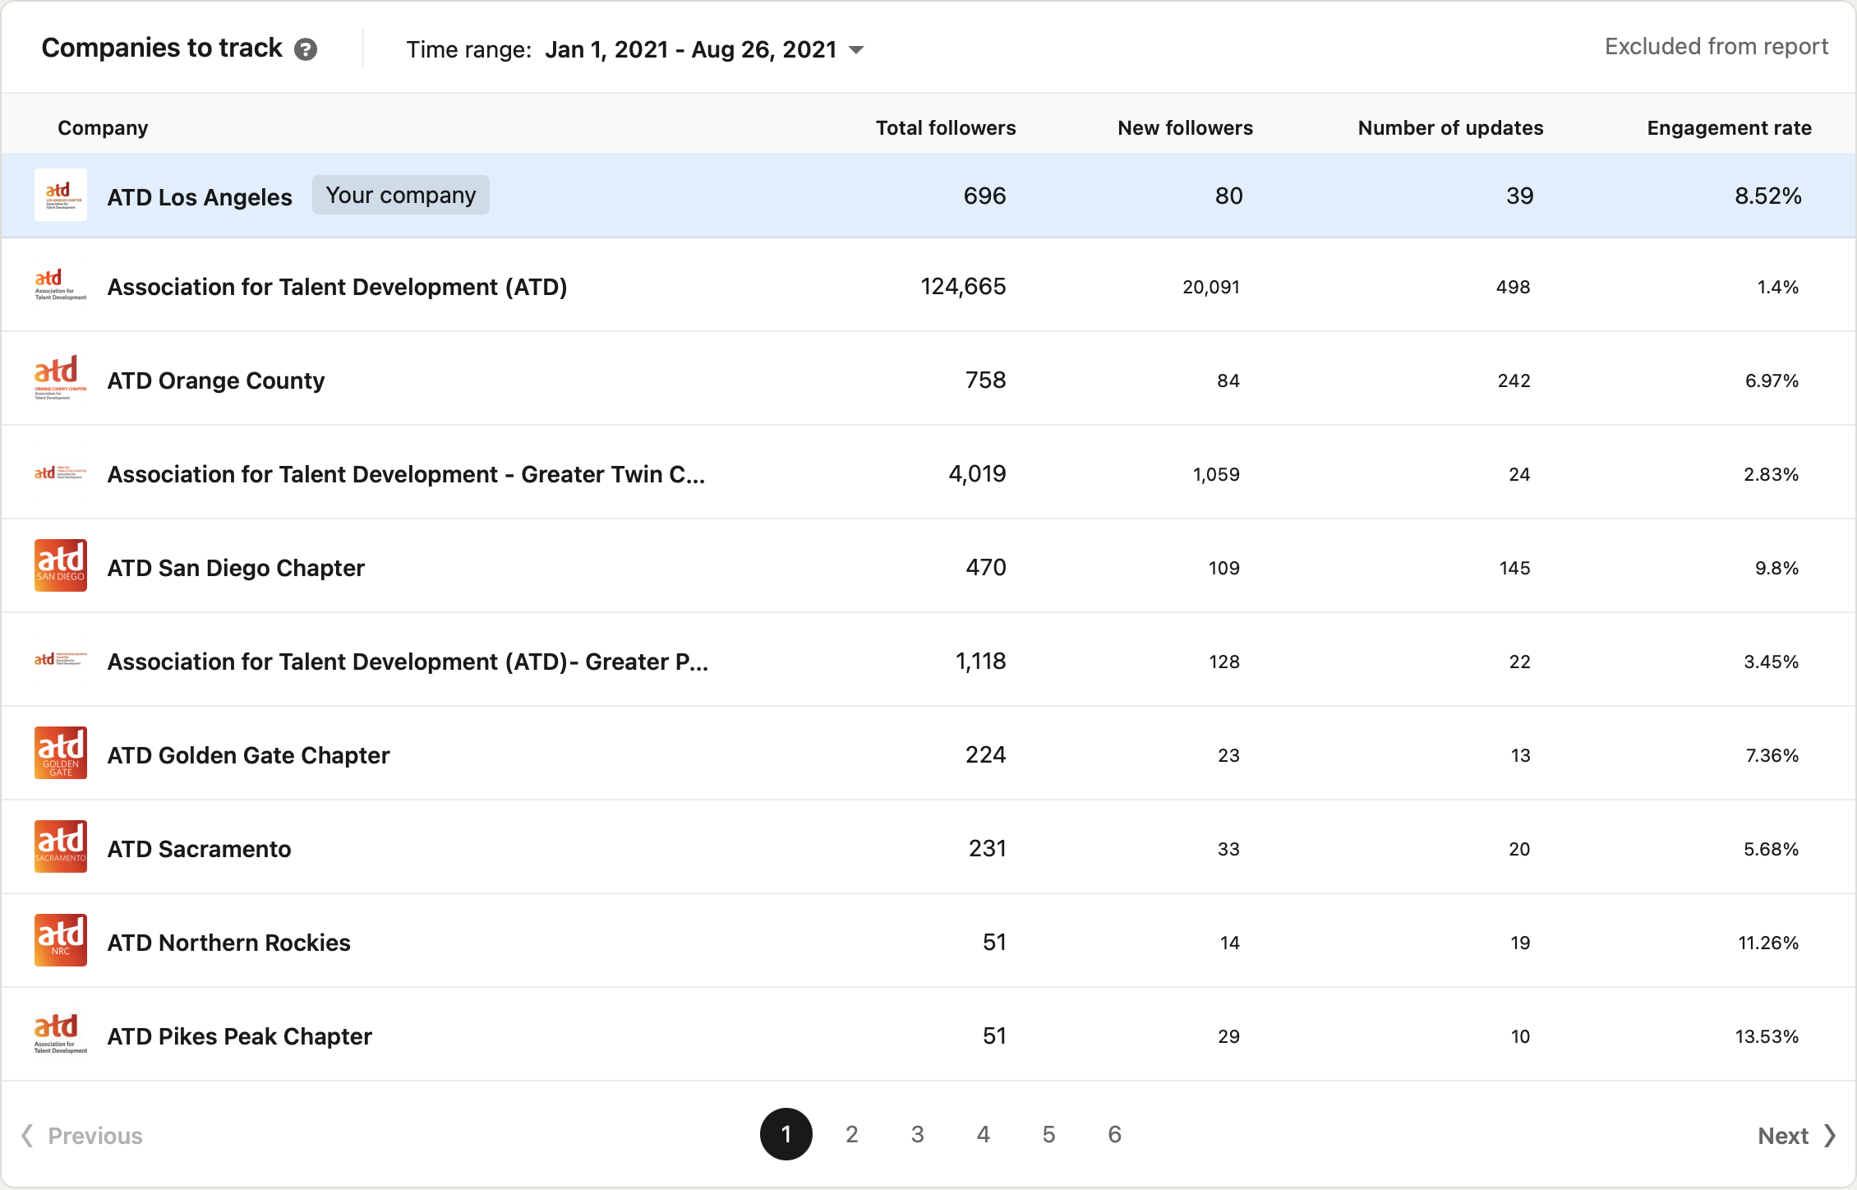
Posts: We reached a peak of 3,000 impressions in April. Impressions have gone down during the summer months.
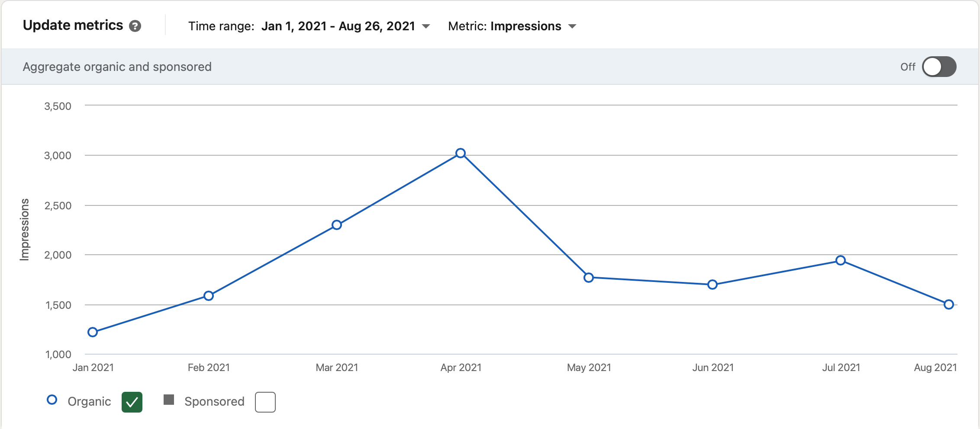

The post with the highest number of impressions, 1,223, was the recognition of Michelle Yang and Nairee Bedikian. Recognition and post-meeting updates give us the highest number of impressions. The post with the highest CTR (clicks/impressions) was the Summer Mixer chapter meeting on August 26 at 9.29%. Post-meeting updates increase engagement.
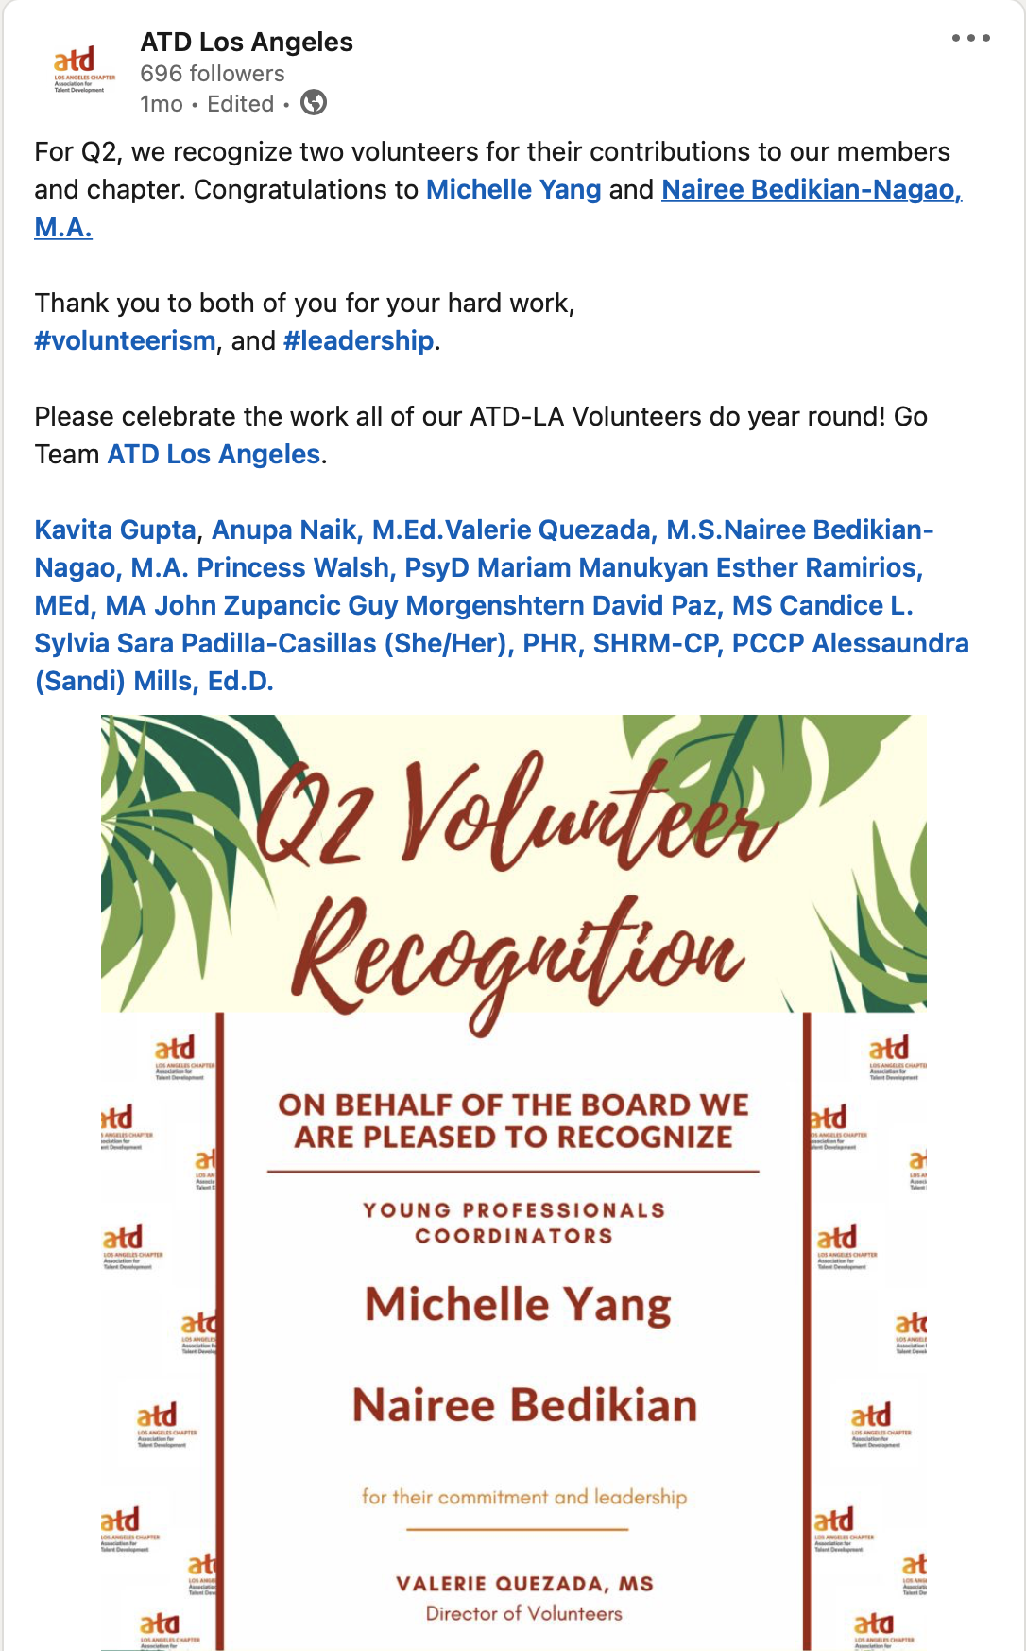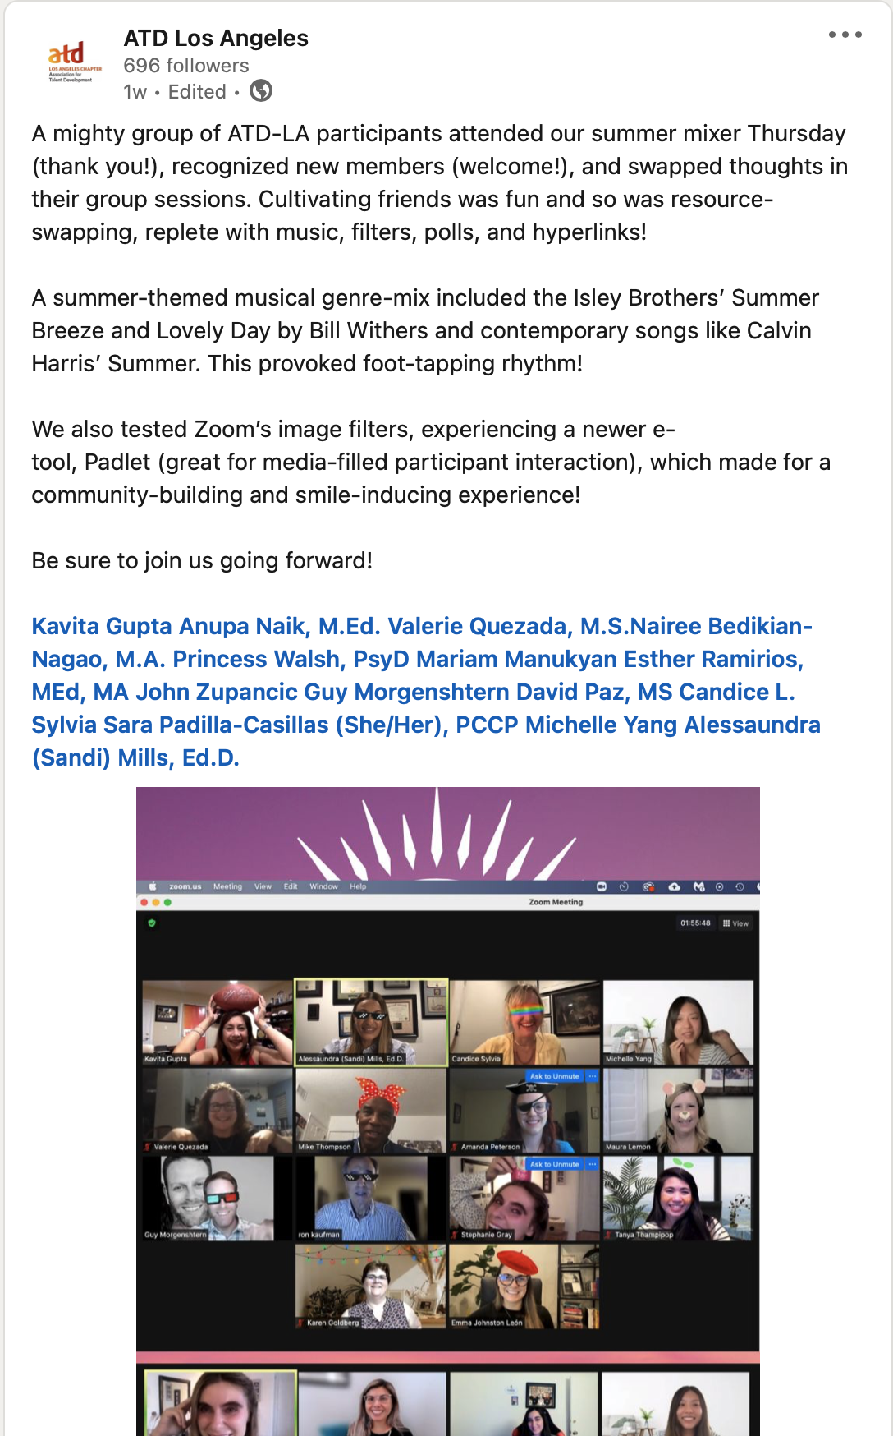

The new year appears to be the best time to attract new members. A more concentrated effort at the beginning of the year might increase these numbers in 2022.
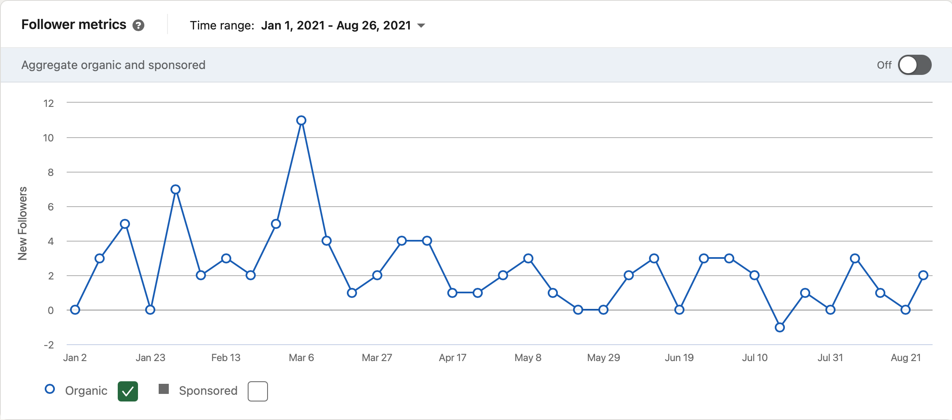

MENTOR PROGRAM REPORT – CHRISTINA BORYK, KEVIN KWAN, JAMES MCKENNA
Program Administrators
Volunteer team of Christina Boryk, Kevin Kwan, and James McKenna, under advisement from Kavita Gupta.

Program Support
Past President Anthony Lewis provided key insights and lessons-learned. Additionally, ATD-LA member Nairee Bedikian shared ideas and lessons from her experience running a mentor program in her organization. Finally, Grant and Denise provided support with communications and event set-up.

External Meetings
Three meetings, including an information session, launch, and closing (scheduled for 10/11/21). The average attendance for these meetings was approx. 30, with 1000+ views on LinkedIn for the kickoff meeting held on March 30, 2021. Sample members' comments from the kickoff meeting include "awesome," "great job," "very nice," "very well done, mentoring team," and "looking forward to this experience. It was what I need to move forward in a new direction in my life, thanks for your time.”

Internal Meetings
The Team met approximately 15 times to develop, launch, monitor, and close the program.

Participants
13 mentors
16 mentees

Resources Created
Program Participant Guide adapted from the original guide created by Past President Anthony Lewis
Resource Padlet
Surveys

Evaluation
A mid program survey was sent in June, receiving over 50% response rate (7/13 mentors, 9/16 mentees); quantitative data follows this chart. A closing survey is in development and will be distributed 2 weeks prior to the closing event to both solicit feedback on the program as well as gather information that will be used in the closing meeting including accomplishments.

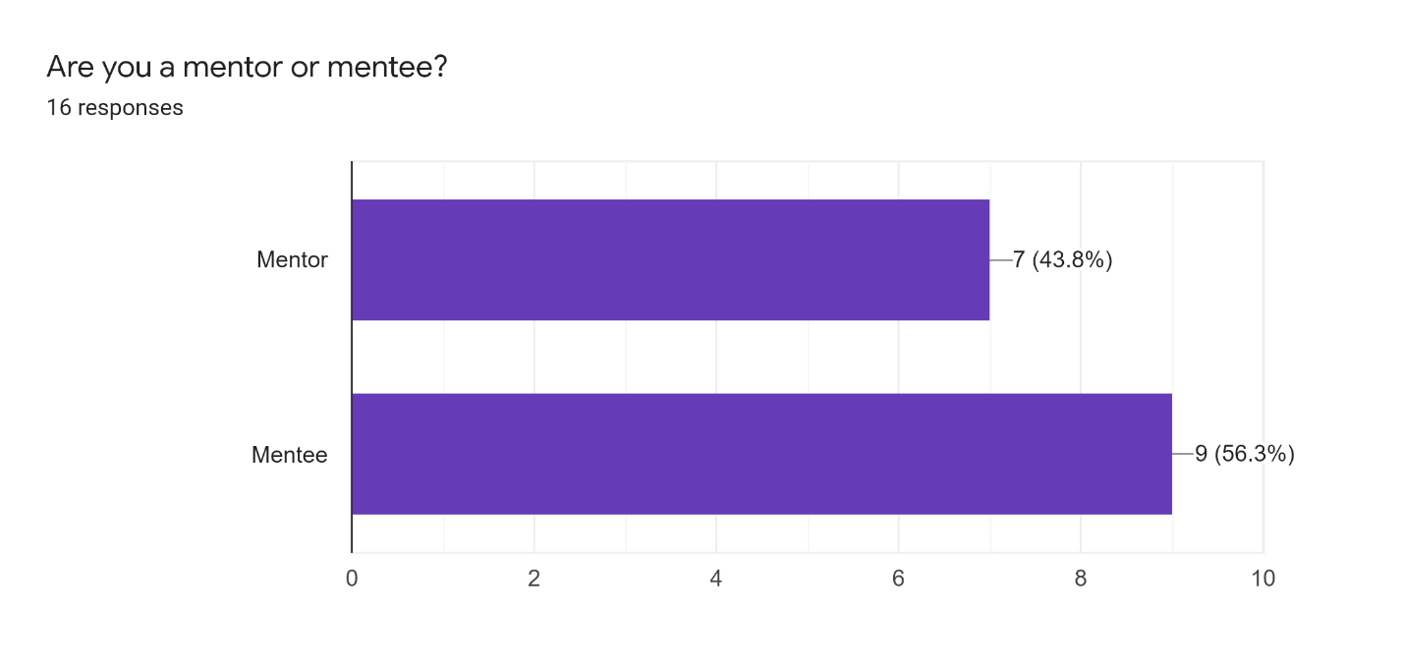

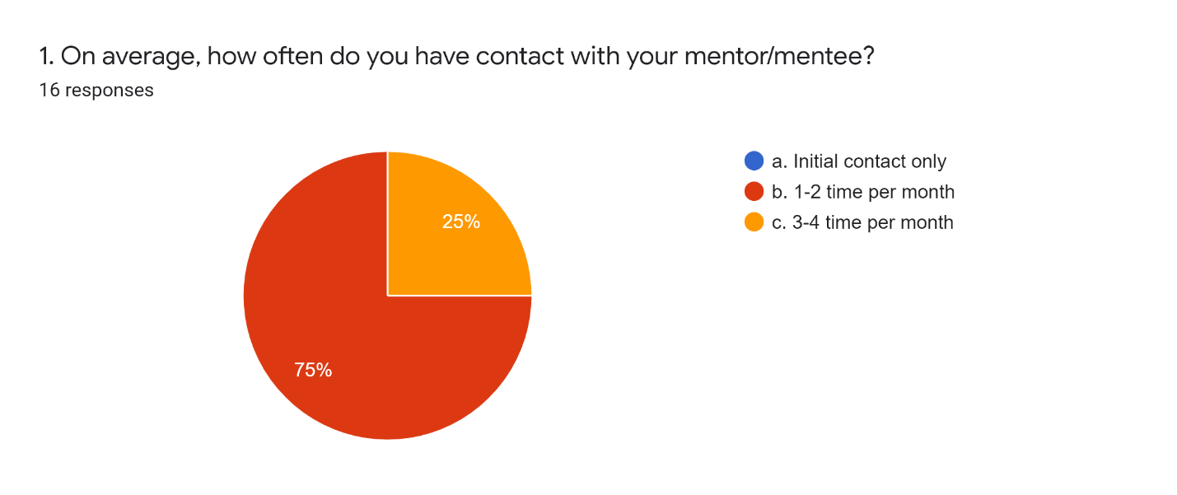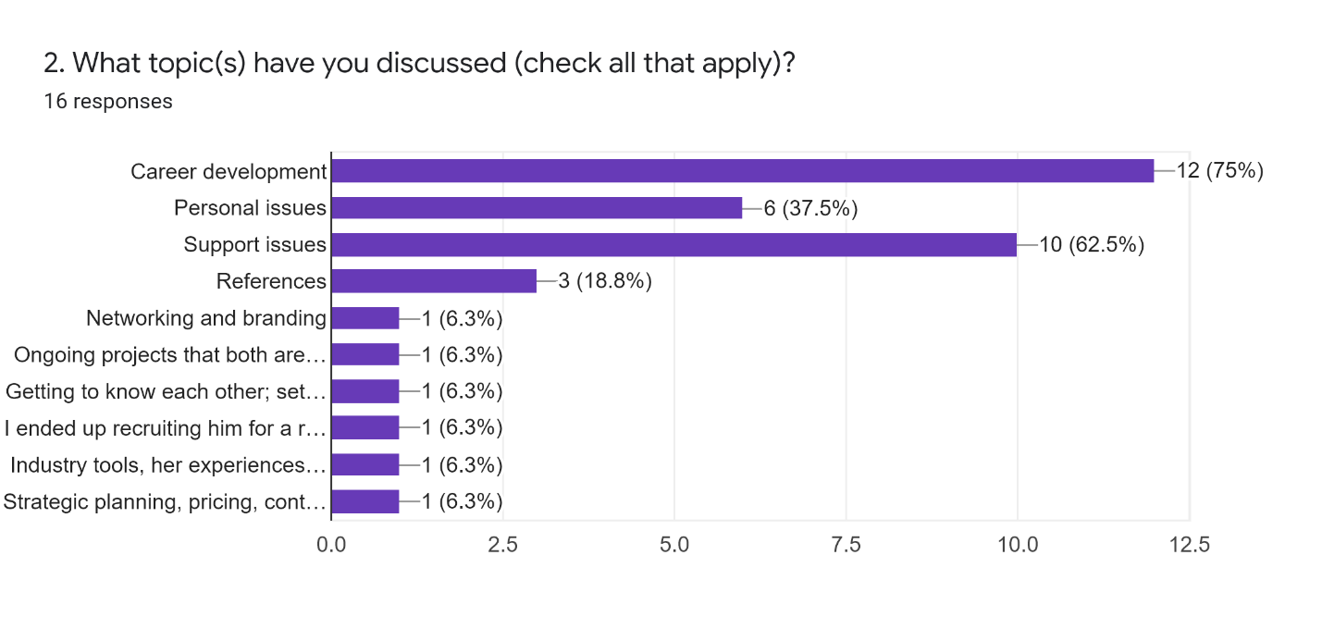
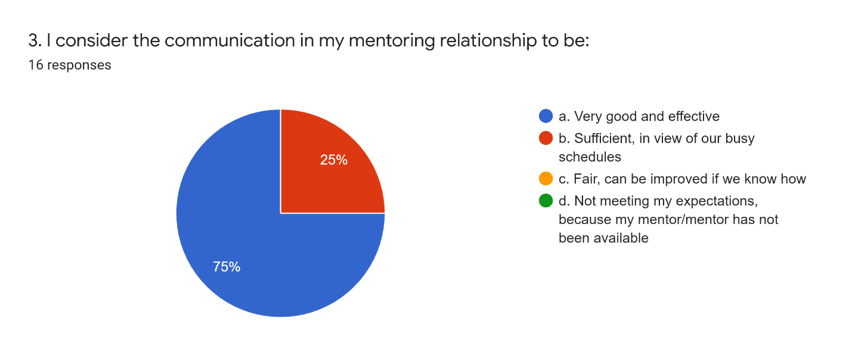
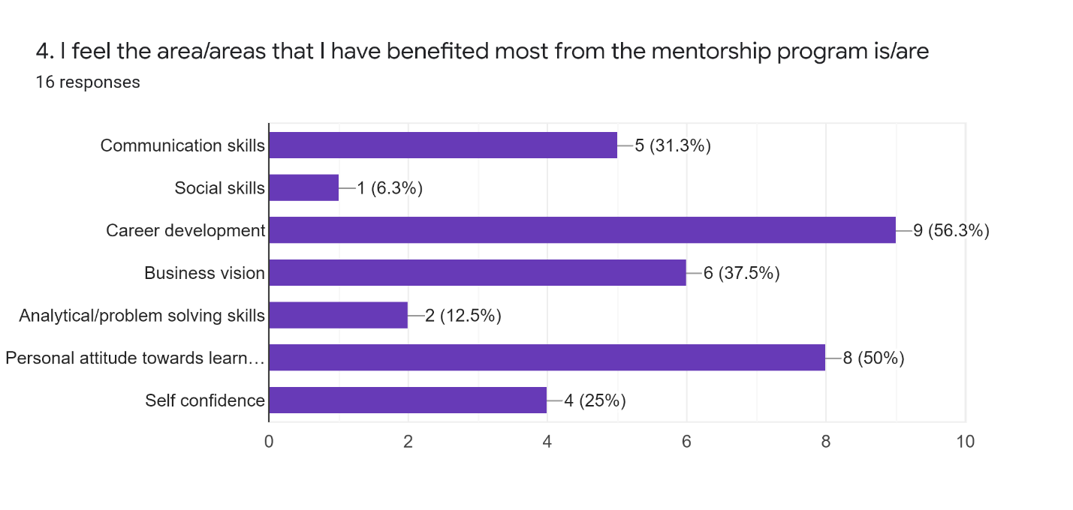

2021 ANNUAL GOALS

COMMUNICATIONS & MARKETING STRATEGY
Goal: Increase ATD-LA’s visibility on the national and global map.
Publicize ATD-LA as a host chapter for the International Conference & Exposition to be held Aug 29 to Sep 2 via social media – LinkedIn, Twitter, the chapter website and sister chapter websites in California.  Market ICE through weekly announcements in the chapter enewsletter beginning in February.  Continue to increase followers on LinkedIn through engaging news posts and announcements (see Social Media Report for statistics). | Completed  Completed  Ongoing in 2022
RECRUITMENT & RETENTION STRATEGY
Goal: Maintain a stable membership base by offering incentives and high quality programs and job opportunities via the job board.
Initiate the 2021 KG Talent Development Fund on January 5 that offers $2,500 to members and non members that qualify for a need-based membership (value $50 each). This grant can potentially bring back or add 50 members in 2021.  Continue to offer 1-hour Orientation webinars five times a year that usually recruit about 60%-75% of prospects/year.  Institute an examination of the current job board and ways to improve and increase the number of job postings.  Recognize volunteers quarterly through a Volunteer Recognition program and chapter leaders through an Annual Recognition and Awards program that was successfully re-launched in December 2020.  Continue to offer professional development opportunities to board members through ATD National complimentary award programs and board incentives such as two $500 cash awards toward an ATD National or ATD-LA certificate program for new board members from 2021-2024. Continue to offer free dinners at in-person chapter meetings and annual gifts to board members and chapter leaders at the Holiday Mixer at the end of the year.  Launch a Young Professionals Network for individuals under 35.  Continue membership retention strategies such as following up on renewals with phone calls to members.  Continue recruitment through discounted membership incentive drives such as Valentine’s Day, Black Friday and summer specials. | 20 grants awarded in 2021, $755 remaining for 2021/2022  Ongoing in 2022  Completed  Ongoing in 2022  Ongoing in 2022  Completed  Completed  Ongoing in 2022
SUCCESSION PLANNING STRATEGY
Goal: Create a pipeline of volunteers that can move into leadership positions and recruit 6-8 volunteers in 2021.
Continue to advertise volunteer opportunities through the Call for Volunteers video https://atdla.org that successfully recruited 12 potential candidates in Fall 2020.  Align one volunteer with each director so that they can shadow and learn the ropes and move into a board role when a director steps down.  Continue to grow the leadership base that grew 54% in 2020. | Ongoing in 2022  Ongoing in 2022  Ongoing in 2022
2022 ANNUAL GOALS GROUP WORK PLAN
Operating plans provide a framework for effectively doing business and efficiently managing resources and explain how the chapter will achieve the outlined goals and objectives, so that chapter activities are consistent and target member needs. As mandated by ATD Global, we will work in groups to draft goals, objectives and define deliverables and a timeline for what we need to accomplish in the following 3 areas. An example is presented below.

DIRECTIONS:

- Review the 2021 Annual Goals on the previous page that were submitted as part of ATD-LA’s Chapter Affiliation Requirements report.
- Use the information from the 2021 Annual Goals, templates and additional material you have been provided to develop new goals for 2022. These goals may be ongoing goals from 2021 or new goals for 2022.
- Come up with 2 or more goals for each area that are realistic and manageable and can be accomplished by the board and/or volunteers within designated timeframes.

- GROUP 1 – COMMUNICATIONS & MARKETING STRATEGY
TEAM LEADER – JOHN ZUPANCIC
TEAM MEMBERS - Sandi Mills, Princess Walsh, Denise Ross

- GROUP 2 – RECRUITMENT & RETENTION STRATEGY
TEAM LEADER – KAVITA GUPTA
TEAM MEMBERS - James McKenna, Maura Lemon, Grant Skakun
Goal 1 (Example): Increase recruitment by x%. Send a monthly communication to prospective chapter members.

- Objective: Identify prospective members by leveraging the ATD state list, LinkedIn, and Wild Apricot records of nonmembers who have recently interacted with the chapter (by attending an event, opening an email, or participating in a webcast). Track nonmembers and develop a plan to follow up with them.

- Tasks and Owners: Membership Director, Office Administrators

- Timeline: Ongoing throughout the year

- GROUP 3 – SUCCESSION PLANNING STRATEGY
TEAM LEADER – VALERIE QUEZADA
TEAM MEMBERS - Sara Padilla-Casillas, Anupa Naik, Mariam Manukyan

ATD-LA COMMUNICATIONS & MARKETING STRATEGY

GOAL 1:

OBJECTIVE:

TASKS & OWNERS:

TIMELINE:

ATD-LA RECRUITMENT & RETENTION STRATEGY

GOAL 1:

OBJECTIVE:

TASKS & OWNERS:

TIMELINE:

ATD-LA SUCCESSION PLANNING STRATEGY

GOAL 1:

OBJECTIVE:

TASKS & OWNERS:

TIMELINE:

