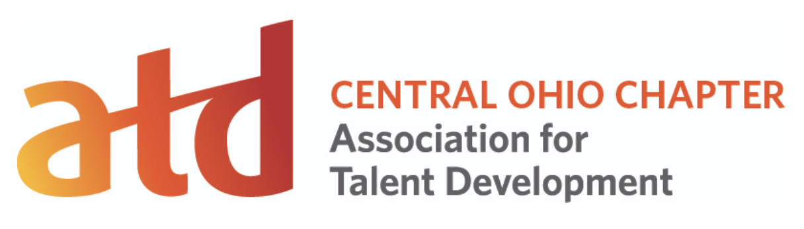

Emerging Professional Showcase & Look & Learn RFP and outline

Emerging Professionals Showcase scheduled for October 3, 2019 at The Ohio State University CETE-1900 Kenny Road, Columbus, OH
We can pick a time from 4:30pm-8:00pm
Are you new to Learning and Development and looking for some feedback? Have you ever wanted to present on an L&D related topic? If you answered yes to either question, we want YOU to be a part of our Emerging Professional Showcase. We define an emerging professional as:
- A student in a learning and development related program AND/OR
- A professional who has been working in Learning and Development for 5 years or less
If selected, you will walk away from our event with presentation experience you can put on your resume/CV and guided feedback (provided in private) from our panel of coaches.
This is not limited to the Columbus, Ohio area, so we are accepting proposals for virtual presentations as well.

Presentation criteria:
Each presentation will be at least 15 minutes each. In order to accommodate as many emerging professionals as possible, we reserve the right to potentially ask for longer presentations.
The program will be a balance of virtual and in-person options. In person presenters will have access to a room with a lectern, computer A/V hookup, microphone, and speakers.
Virtual presenters will be brought in via our web conferencing software by the Emerging Professional Showcase producer and will be displayed in the room via webinar. After presentations are given, any audience questions will be fed back to you in the webinar software.

RFP questions for EPS:
Name,
Title,
Organization
Org Address
Email
Phone Number
How are you an emerging professional (short answer)?
What is the name of your presentation?
Give us a glimpse of your presentation. Describe it in 100 words or less (can use learning objectives, what is in it for the audience, etc).
If selected, will you provide slides/handouts of the presentation to be collected for the full showcase program?
Is there any type of feedback you are requesting from the panel of seasoned L&D folks (presentation voice (filler words), topic, engagement level)?
Are you applying to present virtually (Y or N)?
If yes, do you agree to a pre-showcase meeting with our producer for testing technology?

Chipotle catering will be provided

Look & Learn Information
Curious how others are building in the Learning and Development space? Consider applying to be a “look & learn” participant. This is open to all and there are two divisions with prizes. Prize categories Best of Division and Most Creative.
Emerging Professional Division
L&D Division
Each attendee will be given a scorecard for the Look & Learn.
Best of Division will be awarded to the participant/product who has the most votes from participants in the division. Most creative will be awarded to the participant/product who has the most votes from participants in the creative space? (need help here)

RFP questions for L&L:
Name
Title,
Organization
Org Address
Email
Phone Number
Which Division are you joining (Emerging Professional or L&D)?
What is the name of the product you are demoing?
Give us a glimpse of your product. Describe it in 100 words or less (can use learning objectives, what is in it for the audience, etc).
Do you have permission to share this for demonstration purposes?
Can you provide a link to information about this for our showcase program (ie-shortlink to view, video about it, etc)?

