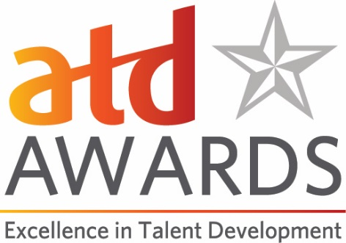

The ATD Talent Development for Good Award
This is a new ATD award category. We are looking for pioneers who changed people’s lives for the better in 2020. Every person and organization made significant changes this year. Some organizations created transformational change in service to others. That’s who this award is for, and we want to hear from you!
The ATD Talent Development for Good Award is given in recognition of organizations that leveraged talent development to make significant contributions to improve the lives of others, changed an industry or community for the better, or served society in a powerful way.
Organizations must demonstrate through their actions and evidence of measurable results that what they did—and may continue to do—is improving the human condition, is something that others can learn from their actions, and is sustainable over time.
Eligibility:
This award is for organizations or entities that have a talent development function. Elected officials are not eligible.
- Entities must have 10 or more full time employees in order to apply.
- You do not need to be an ATD member to apply.
- NOTE for Vendors and Suppliers: Vendors and suppliers may apply for the ATD Talent Development for Good Award under one of these two parameters:
- The application reflects the talent development initiative(s) within the supplier/vendor organization.
- The vendor/supplier partners with a client organization and submits an application under the client organization’s name.

Submission Form:
Please use this document to prepare your application and note the word count limits for questions 1-5. To submit the application, please go to our online awards portal and submit your entry there.
The deadline for submissions is February 15. Please email Erin Strider (estrider@td.org) with questions.
ATD Talent Development for Good Award Application Form
Date of Application:
Name of Nominator (please indicate if this is a self-nomination):
Contact Information for Nominator:
- Name
- Title
- Organization
- Email
- Phone
Nominee Information:
- Name
- Title
- Organization
- Email
- Phone

- Please describe a situation, need, or opportunity that your organization identified in 2020 and how your organization was uniquely positioned to help with this need. (500-word maximum)

- Describe what your organization did—what were the significant contributions, actions, or changes that you instituted and how did they impact an industry, community, or society? (500-word maximum)

- Describe how talent development played a role in the initiative described above. Please share examples, which can include online links or an attachment (maximum of one attachment that is no more than three pages). (500-word maximum)

- Describe the measurable results of your actions—what were the outcomes? Include metrics/data where possible. (500-word maximum)

- How is your work or contribution improving the lives of others and is it sustainable over time? Can others learn from and replicate your work to benefit different populations? (500-word maximum)
- Please describe why your organization is deserving of being chosen for this award. (500-word maximum)

