**SOS Submission Title:** 2019 Midwest ATD Chapter Meet Up w/Sponsor  **Chapter Name:** Kansas City

|  |  |
| --- | --- |
| **Submission Date:** 9.30.19  **ChIP Code:** 6027  **Chapter Location:** Kansas City **Chapter Membership Size:** | **Contact for this Submission:**   * Amy Swaminathan, President Elect, ATD Kansas City * Shannon Swift, President, ATD Kansas City   **Event partners:**   * Jen Wichern, President, ATD Nebraska * Katie Kuhl, President-elect, ATD Nebraska * Danielle Buscher, President, ATD St. Louis   **Email Address:** amy.swaminathan@terracon.com **Phone Number:** 913-568-8049 **Chapter Website URL:** tdkc.org |

*When responding to each area, please provide information about who, what, when, how, why, where, and to what degree where appropriate. Also, please be specific and provide enough detail that would allow a leader from a different chapter to pick up this document and mimic your effort.*

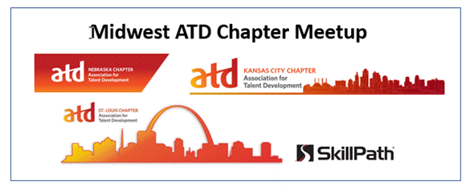

**Description of Effort:**

The **ATD Kansas City Chapter** collaborated with other ATD chapter leaders to host a networking event at the 2019 ATD International Conference & Expo (ICE). The event, **Midwest ATD Chapter Meetup,** was sponsored by SkillPath, an ATDKC local sponsor, and a Platinum sponsor at ATD ICE. By leveraging our local sponsorship relationship with SkillPath, we were able to “join forces” and co-host a meet-up event for other local chapters to network.

To widen our opportunity to reach attendees in our local area, the ATD Kansas City chapter partnered with ATD Nebraska (Omaha) and ATD St. Louis board members to invite attendees in our chapter zip code reach to meet our goal to provide a networking experience for ATD members attending ICE who may or may not been local chapter members. We had heard that many ATD ICE attendees do not know about local ATD chapters in their area. This was an opportunity for us to build our regional community, impact chapter membership and share a sponsor relationship with other chapters.

By working with a sponsor, the room rental and drink minimum was generously paid for. Our sponsor had their own invite out to VIP clients and saw that working with local ATD chapters, they could broaden their networking reach by meeting new contacts. SkillPath asked us to commit to the cost for 50 attendees that would be invited and tracked through a separate event invite. Being non-profit, we all had to get budgets approved by our boards. We (ATD KC, ATD St. Louis and ATD NE) agreed to split the cost of 50 attendees (food).

**ATD offered to help us with the invite distribution** to ICE Attendees (national and local members) within our chapter zip code radius. We provided our chapter zip codes and the invite link/details to ATD National (Samantha Herman) who then distributed an email to ATD ICE attendees. This ensured that ATD ICE attendees didn’t feel that their personal information was being shared without their permission. It was the right thing to do and it paid off. Once the ATD endorsed email went out the event filled to the 50 capacity in one business day! We had to politely decline many people who wanted to sign up and join the networking event.

ATD will run a report of all ICE registrants who are national, chapter and national-only and send out an email on our behalf. Since the list of national attendees in our respective cities who are not members of our local chapters is a prospective group ATD can help us all reach.

**Message Sent by ATD on behalf of ATD Kansas City, ATD St. Louis and ATD Nebraska**

Dear Amy,

The [Kansas City](http://www.tdkc.org/), [Nebraska](http://www.atdnebraska.org/), and [St. Louis](http://www.atdstl.org/) chapters of ATD are interested in connecting with people from their areas while at the 2019 ATD International Conference and Exposition by hosting a meetup event. Below is an email I am sending on behalf of the chapters. Please RSVP directly through the link below if you are interested.

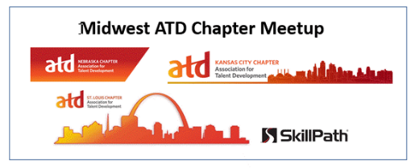

Dear ATD International Conference attendee,

**The Midwest ATD local chapters** would like to invite you to a *free* invitation-only networking event on **Monday night, May 20th**, during the ATD International Conference and Expo in Washington**,** DC.

You are receiving this invitation because you are registered to attend the conference and live in Kansas, Missouri, Nebraska or Southern Illinois. The chapters hosting the event are the following:

·       [ATD Kansas City](https://tdkc.org/)

·       [ATD Nebraska](http://www.atdnebraska.org/)

·       [ATD St. Louis](https://atdstl.org/)

This will be a perfect opportunity to relax after a long day of learning and to network with others from the Midwest. Host chapter members will be there to network with you and share information about local and regional programming, learning events, and virtual learning offered by Midwest chapters. Food and drinks will be provided from **5:00pm till 8:00pm on Monday, May 20th**, at the **Renaissance Hotel**, 999 9th Street NW, one block away from the Convention Center.

We are partnering with [SkillPath](https://skillpath.com/), a Premier sponsor at ATD 2019 and a gold sponsor of ATD Kansas City, to host this event. Space is limited! Click[**here**](https://www.squadup.com/hosts/5199625/events) to register soon!

Once registered for this free event you’ll receive a ticket with a QR code for easy event check-in. We look forward to meeting you!

Sincerely,

Midwest Chapter Leaders – ATD Kansas City, ATD St. Louis and ATD Nebraska

**Recommended Invite Tool**

The invitation tool we used was [www.squadup.com](http://www.squadup.com) for the following reasons:

* FREE
* Easy to set up an event RSVP limit
* Offered multiple fields we could customize (member of a local chapter? Zip code, etc.)
* Mobile-friendly – QR code generator and ticket generator
* Ability to hide the guest list
* Ability to send reminder, etc.
* Ability to download a CSV of the registrants

By utilizing the CSV feature, we were able to download the entire list of registered attendees to sort by zip code. It turned out that there was a balanced mix of registrants across the three local chapter geographical regions (zip code lists). Each chapter representative had a list of registrants in their area before the event, so they could do a cross-reference to see if any of the registered attendees were members of their local chapter. This list helped us justify our chapter investment.

**Cross-Promotion**

Each participating chapter agreed to cross-promote each other chapter’s Fall Conference. The ATD Kansas City chapter had mini business cards made to promote our fall event. In addition, each chapter highlighted all Fall Conference information on each local chapter website (ATD Kanas City, ATD St. Louis and ATD Nebraska). Our ATD Nebraska partner even promoted our Fall Conference in a LinkedIn Post.

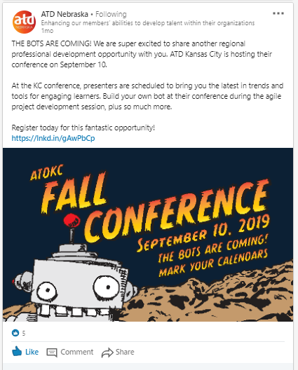

**Event alignment with ATD Mission**

**ATD Mission:**Empower professionals to develop knowledge & skills successfully.

**ATD Kansas City**

Our mission is to promote excellence in the field of learning and development. We encourage active participation, learning and the exchange of ideas to assist members in career and leadership development, organizational effectiveness and profitability, performance improvement and the advance of human resource development.

**ATD St. Louis**

We empower professionals to develop the knowledge, skills, and behaviors critical to success through learning and networking opportunities.

**ATD Nebraska**

Our *mission* is to enhance members’ abilities, to develop talent and support clients and organizations in our local and global communities.

The event was promoted to attendees as an opportunity to meet others, unwind after a long day at the conference and share #ATD2019 highlights with other meetup participants. It turned out to be more than that. There were lots of conversation and sharing around what is being offered in local areas for continued development and community building amongst Talent Development professionals. What we accomplished together exemplified our chapter missions and ATD National, while having a great time!

**Costs**

We requested commitment from participating chapters (St. Louis and Nebraska), to divide the overage costs between our three chapters. This had to go through a BOD approval vote for each chapter. SkillPath, our sponsor, picked up the cost of the room rental and 50 of their own invites. They also covered the bar tab.

|  |  |  |  |
| --- | --- | --- | --- |
| **SkillPath Commitment** |  | ATD Chapter Commitment | Anticipated Costs |
| Room rental | $1,500 |  | $0 |
| Food for up to 50 guests @ $45 pp | $2,250 | Cover overage ($45 pp) for 50 people | $2,250 (split between 3 chapters - $750 |
| Open Bar  (5-8PM) |  |  | $0 |

**Resources/Volunteers**

Our contacts arrived early to set up and help check people in by checking them off our registration list. Chapter members (ATD Kansas City) were all given several Fall Conference “save the date” cards and were prepped about the opportunity to connect with others at the event.

|  |  |
| --- | --- |
| **Chapter** | **Contact for event** |
| **ATD Kansas City** | **Angela Buzard, Director of Events** (she will be our POC for the event). Also, in attendance:   * Megan Galloway, Director of Social Media * Amy Swaminathan, President-Elect |
| **ATD Nebraska** | **Jen Wichern**, President  **Katie Kuhl**, President-Elect |
| **ATD St. Louis** | **Michelle Rodgers**  **Susan Plank** |

**Outcomes**

**Example of RSVP data and message sent to ATD chapter partners:**

We’ve reached our 50 capacity! 😊 SkillPath has reached their 50-capacity limit as well. If you are bringing collateral, please expect 100 people at this event! Thank you again! So excited for this fantastic networking opportunity for Midwest ATD members.

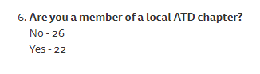

|  |  |
| --- | --- |
| **Member (Chapter Name) - 22** | **Non-Member – 26 (zip codes)** |
| Kansas City – 7 | 8 |
| St. Louis - 9 | 7 |
| Nebraska – 5 | 5 |
| Northwest Arkansas – 1 | Columbia, MO – 1 |
|  | Springfield, MO – 2 |
|  | Wichita, KS – 2 |
|  | Garden City, KS – 1 |

**P.S.** I’ve edited the text of the invite to include the following:

**This event has been SOLD OUT!**

**Tickets can be transferred by the ticket holder. There is no wait list.**

**Thank you so much for your interest in the Midwest ATD chapters.**

Please visit our links below to find out more about chapter membership and events.

**Success Stories**

**We’ve been able to track 2 new chapter members (Kansas City) and St. Louis has been able to track 1 new chapter member from that event.**

“One of my first conversations was with a TD professional who supports the City of Kansas City government team. She was delightful to talk with and had no idea that there was a local Kansas City chapter. We shared business cards and I followed up with her after the event. She has joined our chapter, along with one of her colleagues. This was a huge win for us!” – Amy Swaminathan

In addition, SkillPath, our sponsor, was so thrilled with the attendance and positive engagement and communication with our three chapters that they have committed to go BIGGER next year!

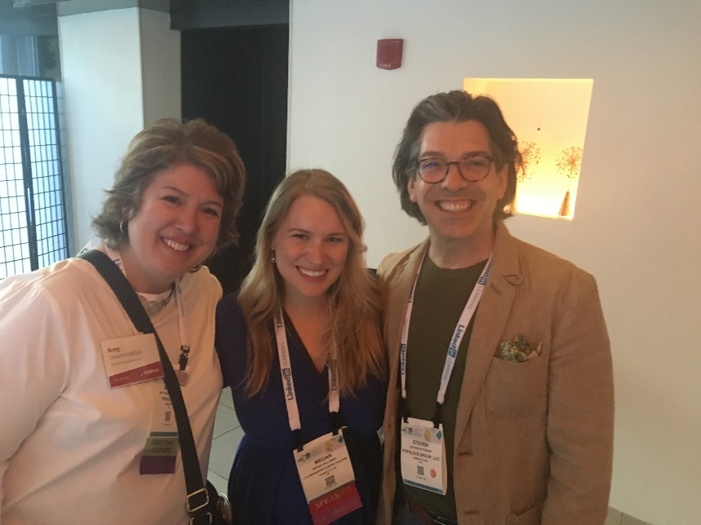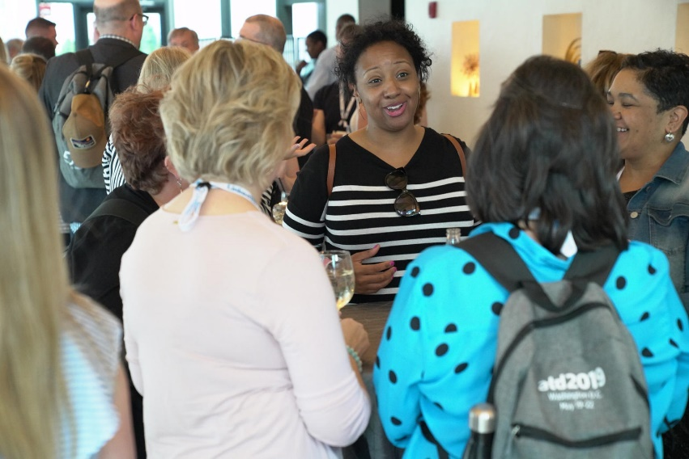

**Lessons Learned:** *(Hints and tips for other Chapters who may be considering a similar effort)*

1. Get your VP of Finance involved from the start to be a part of all budget conversations with a sponsor and partnering chapters.
2. Refer to other SOS submissions for ideas and considerations.
3. Partner with ATD National partners (i.e. Samantha Herman)
4. **Wear comfortable shoes!** It’s a long day at ATD ICE and just when you think you have no energy left, there is always a surge of energy networking with others. It was a 14-hour day that was awesome from start to finish!

**How did you become familiar with the Sharing Our Success (SOS) program?** ATD ICE Chapter Leader’s Day.

***Please email completed forms to*** [***SOS@td.org***](mailto:SOS@astd.org) ***along with any supporting documents.***